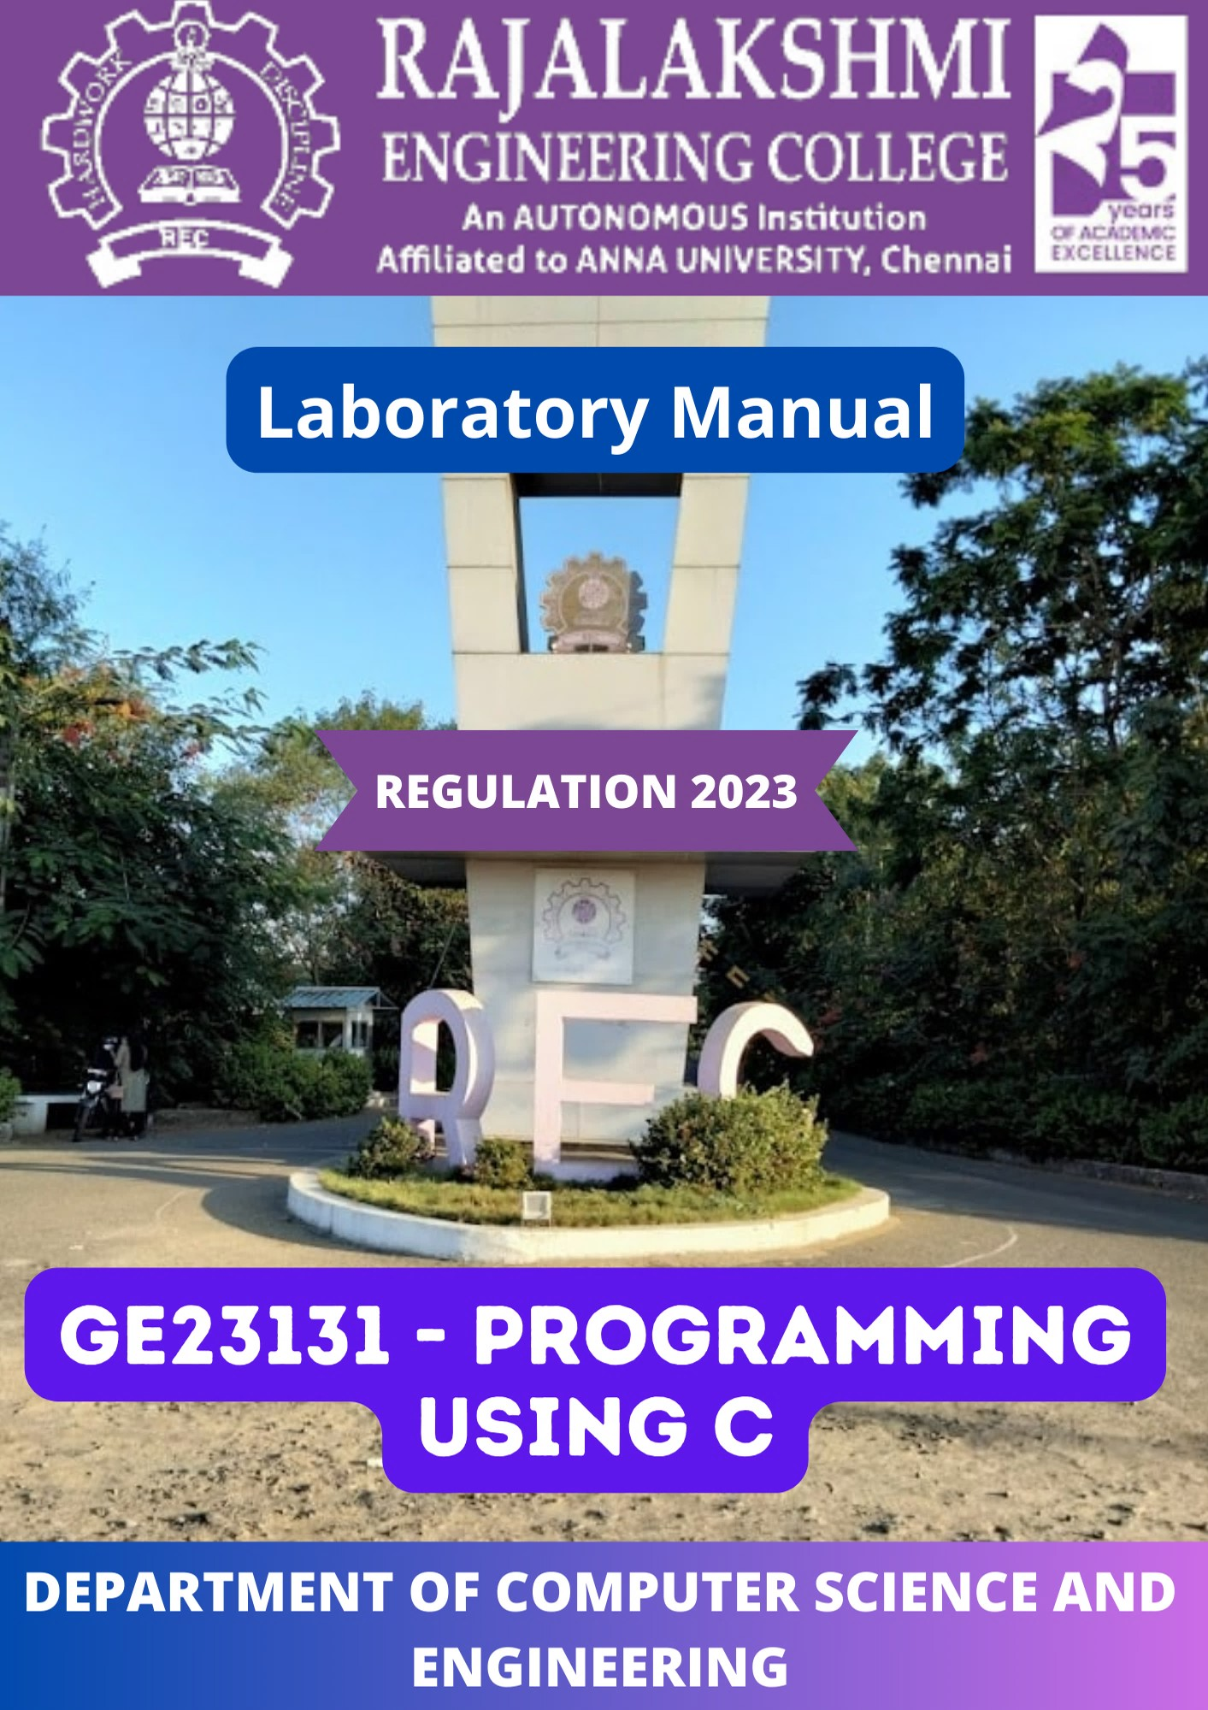

RAJALAKSHMI ENGINEERING COLLEGE

**An Autonomous Institution, Affiliated to Anna University Rajalakshmi Nagar, Thandalam – 602 105**



# DEPARTMENT OF COMPUTER SCIENCE AND ENGINEERING

|  |
| --- |
| **GE23131 - PROGRAMMING USING C**  **(*Regulation 2023*)** |
| **LABORATORY MANUAL** |

**Name**

**Register No**.

: .A. . ...A. . v. .i.n. .a. .s.h. . . . . . . . . . . . . . . . . . . . . . . . . . . . . .

: .2. .4.0. .7.0. .1. 0. .6. 6. . . . . . . . . . . . . . . . . . . . . . . . . . . . . . . .

**Year / Branch / Section** : 1. . s. .t. y. .e. a. .r. .C. .S. E. . .'.B. '. . . . . . . . . . . . . . . . . . . . . . . . .

**Semester**

**Academic Year**

: 1. . s. .t. s. .e. m. . .e. s. .te. .r. . . . . . . . . . . . . . . . . . . . . . . . . . . . .

: .2. 0. .2. 4. .-.2. 0. .2. 5. . . . . . . . . . . . . . . . . . . . . . . . . . . . . . . . .

## RAJALAKSHMI ENGINEERING COLLEGE

**An Autonomous Institution, Affiliated to Anna University**

**Vision**

To be an institution of excellence in Engineering, Technology and Management Education & Research.

To provide competent and ethical professionals with a concern for society.

**Mission**

To impart quality technical education imbibed with proficiency and humane values. To provide the right ambience and opportunities for the students to develop into creative, talented, and globally competent professionals. To promote research and development in technology and management for the benefit of society.

**DEPARTMENT OF COMPUTER SCIENCE AND ENGINEERING**

**Vision**

To promote highly ethical and innovative computer professionals through excellence in

teaching, training, and research.

**Mission**

To produce globally competent professionals, motivated to learn the emerging technologies and to be innovative in solving real world problems.

To promote research activities amongst the students and the members of faculty that could benefit the society.

To impart moral and ethical values in their profession.

**PROGRAM OUTCOMES (POs)**

A graduate of the Computer Science and Engineering Program will demonstrate:

**PO1**: Engineering knowledge: Apply the knowledge of mathematics, science, engineering fundamentals, and an engineering specialization to the solution of complex engineering problems.

**PO2**: Problem analysis: Identify, formulate, review research literature, and analyze complex engineering problems reaching substantiated conclusions using first principles of mathematics, natural sciences, and engineering sciences.

**PO3**: Design/development of solutions: Design solutions for complex engineering problems and design system components or processes that meet the specified needs with appropriate consideration for the public health and safety, and the cultural, societal, and environmental considerations.

**PO4**: Conduct investigations of complex problems: Use research-based knowledge and research methods including design of experiments, analysis and interpretation of data, and synthesis of the information to provide valid conclusions.

**PO5**: Modern tool usage: Create, select, and apply appropriate techniques, resources, and modern engineering and IT tools including prediction and modeling to complex engineering activities with an understanding of the limitations.

**PO6**: The engineer and society: Apply reasoning informed by the contextual knowledge to assess societal, health, safety, legal and cultural issues and the consequent responsibilities relevant to the professional engineering practice.

**PO7**: Environment and sustainability: Understand the impact of the professional engineering solutions in societal and environmental contexts, and demonstrate the knowledge of, and need for sustainable development.

**PO8**: Ethics: Apply ethical principles and commit to professional ethics and responsibilities and norms of the engineering practice.

**PO9**: Individual and teamwork: Function effectively as an individual, and as a member or leader in diverse teams, and in multidisciplinary settings.

**PO10**: Communication: Communicate effectively on complex engineering activities with the engineering community and with society at large, such as, being able to comprehend and write effective reports and design documentation, make effective presentations, and give and receive clear instructions.

**PO11**: Project management and finance: Demonstrate knowledge and understanding of the engineering and management principles and apply these to one’s own work, as a member and leader in a team, to manage projects and in multidisciplinary environments.

**PO12**: Life-long learning: Recognize the need for and have the preparation and ability to engage in independent and life-long learning in the broadest context of technological change.

**PROGRAM SPECIFIC OUTCOMES (PSOs)**

A graduate of the Computer Science and Engineering Program will demonstrate:

**PSO1: Foundation Skills:** Ability to understand, analyze and develop computer programs in the areas related to algorithms, system software, web design, machine learning, data analytics, and networking for efficient design of computer-based systems of varying complexity. Familiarity and practical competence with a broad range of programming language and open- source platforms.

**PSO2: Problem-Solving Skills:** Ability to apply mathematical methodologies to solve computational task, model real world problem using appropriate data structure and suitable algorithm. To understand the Standard practices and strategies in software project development using open-ended programming environments to deliver a quality product.

**PSO3: Successful Progression:** Ability to apply knowledge in various domains to identify research gaps and to provide solution to new ideas, inculcate passion towards higher studies, creating innovative career paths to be an entrepreneur and evolve as an ethically social responsible computer science professional.

## Rajalakshmi Engineering College

**Department of Computer Science and Engineering Safety Precautions to be Followed in the Computer Laboratory**

### Do’s

1. Know the location of the fire extinguisher and the first aid box and how to use them in case of an emergency.
2. Read and understand how to carry out an activity thoroughly before coming to the laboratory.
3. Report fires or accidents to your lecturer/laboratory technician immediately.
4. Report any broken plugs or exposed electrical wires to your lecturer/laboratory technician immediately.

### Don’ts

1. Do not eat or drink in the laboratory.
2. Avoid stepping on electrical wires or any other computer cables.
3. Do not open the system unit casing or monitor casing particularly when the power is turned on. Some internal components hold electric voltages of up to 30000 volts, which can be fatal.
4. Do not insert metal objects such as clips, pins and needles into the computer casings. They may cause fire.
5. Do not remove anything from the computer laboratory without permission.
6. Do not touch, connect or disconnect any plug or cable without your

lecturer/laboratory technician’s permission.

1. Do not misbehave in the computer laboratory.



# SYLLABUS

|  |  |  |  |  |  |  |
| --- | --- | --- | --- | --- | --- | --- |
| **Course Code** | **Course Title** | **Category** | **L** | **T** | **P** | **C** |
| **GE23131** | **PROGRAMMING USING C** | **ES** | **1** | **0** | **6** | **4** |

|  |
| --- |
| **Objectives:** |
| * To develop C Programs using basic programming constructs |
| * To develop C programs using arrays and strings |
| * To do searching and sorting algorithms in C |
| * To develop applications in C using user defined functions and recursive functions |
| * To develop applications in C using pointers and structures |

|  |  |  |  |
| --- | --- | --- | --- |
| **List of Experiments** | | | |
| **1** | Overview of C, Constants, Variables and Data Types | | |
| **2** | Operators and Expressions, Managing Input and Output Operations | | |
| **3** | Decision Making and Branching | | |
| **4** | Decision Making and Looping | | |
| **5** | Nested Loops - while and for, Jumps in Loops | | |
| **6** | One-Dimensional Arrays | | |
| **7** | Searching Algorithms - Linear and Binary | | |
| **8** | Sorting Algorithms - Bubble and Selection | | |
| **9** | Two-Dimensional and Multi-dimensional Arrays | | |
| **10** | Character Arrays and Strings Handling Functions | | |
| **11** | User-Defined Functions - Recursive Functions | | |
| **12** | Passing Arrays and Strings to Functions | | |
| **13** | Scope, Visibility and Lifetime of Variables | | |
| **14** | Structures and Unions | | |
| **15** | Pointers | | |
| **16** | The Preprocessor | | |
| **Platform Needed:** GCC Compiler for Windows/Linux | | **Total Contact Hours** | **75** |

|  |
| --- |
| **Text Book(s):** |
| 1. Brian W. Kernighan and Dennis M. Ritchie, “The C Programming Language”, Second  Edition, PHI |
| 2. Byron Gottfried, “Programming in C”, Second Edition, Schaum Outline Series |

|  |
| --- |
| **Reference Books(s):** |
| 1. Herbert Schildt, “C: The Complete Reference”, Fourth Edition, McGraw Hill. |
| 2. YashavantKanetkar, “Let Us C”, BPB Publications |
| 3. E. Balagurusamy, Programming in ANSI C, Tata McGraw-Hill |
| 4. NPTEL course , “Problem Solving Through Programming In C”, By Prof. Anupam  Basu, IIT Kharagpur |

|  |
| --- |
| **Course Outcomes:** On completion of the course, the students will be able to |
| * Formulate simple algorithms for arithmetic and logical problems. |
| * Implement conditional branching, iteration and recursion. |
| * Decompose a problem into functions and synthesize a complete program using divide and conquer approach. |
| * Use arrays, pointers and structures to formulate algorithms and programs. |
| * Apply programming to solve matrix addition and multiplication problems and searching and sorting problems. |
| **Suggested Activities** |
| Practice small and tricky codes  Practice problems in portals like Digital Café Debugging the codes  Completing the function definitions etc |

**CO - PO – PSO matrices of course**

|  |  |  |  |  |  |  |  |  |  |  |  |  |  |  |  |
| --- | --- | --- | --- | --- | --- | --- | --- | --- | --- | --- | --- | --- | --- | --- | --- |
| **PO/PSO CO** | **PO 1** | **PO 2** | **PO 3** | **PO 4** | **PO 5** | **PO 6** | **PO 7** | **PO 8** | **PO 9** | **PO 10** | **PO 11** | **PO 12** | **PSO 1** | **PSO 2** | **PSO 3** |
| GE23131.1 | 1 | 2 | 2 | 2 | 1 | - | - | - | 1 | 2 | 1 | 1 | 2 | 3 | - |
| GE23131.2 | 1 | 1 | 1 | 1 | 1 | - | - | - | - | - | 1 | 1 | 2 | 2 | - |
| GE23131.3 | 1 | 1 | 2 | 1 | 1 | - | - | - | - | - | 1 | 1 | 2 | 2 | - |
| GE23131.4 | 2 | 2 | 3 | 2 | 1 | - | - | - | 1 | - | 2 | 1 | 2 | 2 | 2 |
| GE23131.5 | 2 | 2 | 3 | 2 | 1 | - | - | - | - | - | 2 | 1 | 2 | 2 | 2 |
| **Average** | 1.4 | 1.6 | 2.2 | 1.6 | 1.0 | - | - | - | 1.0 | 2.0 | 1.4 | 1.0 | 2.0 | 2.2 | 2.0 |

Correlation levels 1, 2 or 3 are as defined below:

1: Slight (Low) 2: Moderate (Medium) 3: Substantial (High) No correlation: “- “

|  |  |  |  |  |  |
| --- | --- | --- | --- | --- | --- |
| **Course Code** | **Course Title**  **(Laboratory Integrated Theory Course)** | **L** | **T** | **P** | **C** |
| **GE23131** | **Programming Using C** | **1** | **0** | **6** | **4** |

|  |  |  |
| --- | --- | --- |
| **LIST OF EXPERIMENTS** | | |
| **Sl. No** | **Name of the experiment** | **No of Hours** |
| Week 0 | Introduction to Algorithm & Flowcharts | 1L, |
| Week 1 | Overview of C, Constants, Variables and Data Types | 2L, 5P |
| Week 2 | Operators and Expressions, Managing Input and Output Operations | 2L, 5P |
| Week 3 | Decision Making and Branching & Switch-Case | 2L, 5P |
| Week 4 | Decision Making and Looping | 2L, 5P |
| Week 5 | Nested Loops- While and for, Jumps in Loops (Continue and Break) | 2L, 5P |
| Week 6 | One-Dimensional Arrays | 2L, 5P |
| Week 7 | Searching Algorithms - Linear and Binary | 2L, 5P |
| Week 8 | Sorting Algorithms - Bubble and Selection | 2L, 5P |
| Week 9 | Two Dimensional and Multidimensional Arrays | 2L, 5P |
| Week 10 | Character Arrays | 2L, 5P |
| Week 11 | String Handling Functions | 2L, 5P |
| Week 12 | User-defined functions - Recursive functions | 2L, 5P |
| Week 13 | Passing Arrays and Strings to functions | 2L, 5P |
| Week 14 | Structures and Unions | 2L, 5P |
| Week 15 | Pointers | 2L, 5P |
| Week 16 | Scope, Visibility and Lifetime of Variables, The Preprocessor | 2L, 5P |

|  |  |  |  |  |
| --- | --- | --- | --- | --- |
| **S. No.** | **Name of the Experiment** | **Expt. Date** | **Page No** | **Faculty Sign** |
|  | | | | |
| **Week 0** | **Algorithm and Flowchart** | | | |
| I | Calculate Area and Perimeter | 25.9.24 |  |  |
| II | Days to Year Conversion | 25.9.24 |  |  |
| III | Prime Number | 25.9.24 |  |  |
| IV | Leap Year | 25.9.24 |  |  |
| V | Palindrome Number | 25.9.24 |  |  |
| VI | Sum of Digits | | | |
|  | | | | |
| **Week 1** | **Overview of C, Constants, Variables and Data Types** | | | |
| 1 | Say "Hello, World!" With C | 4.10.24 |  |  |
| 2 | Playing with Characters | 4.10.24 |  |  |
| 3 | Sum and Difference of Two Numbers | 4.10.24 |  |  |
| 4 | Average Marks | 4.10.24 |  |  |
| 5 | Basic Data Types | 4.10.24 |  |  |
| 6 | ASCII Value and Adjacent Characters | 4.10.24 |  |  |
|  | | | | |
| **Week 2** | **Operators and Expressions, Managing Input and Output Operations** | | | |
| 7 | Height Units | 9.10.24 |  |  |
| 8 | Arithmetic | 9.10.24 |  |  |
| 9 | Day Old Bread | 9.10.24 |  |  |
| 10 | Goki and his Breakup | 9.10.24 |  |  |
| 11 | Say no to Handshakes!!! | 9.10.24 |  |  |
| 12 | Back to School | 9.10.24 |  |  |
|  | | | | |
| **Week 3** | **Decision Making and Branching - if, if...else and nested if…else, if…else if, Switch-Case** | | | |
| 13 | Same Digit | 18.10.24 |  |  |
| 14 | Intro to Conditional Statements | 18.10.24 |  |  |
| 15 | Pythagorean Triples | 18.10.24 |  |  |
| 16 | Name That Shapes | 18.10.24 |  |  |
| 17 | Chinese Zodiac | 23.10.24 |  |  |
| 18 | What Color Is That Square? | 23.10.24 |  |  |
| 19 | Day of Year | 23.10.24 |  |  |
| 20 | Suppandi & Areas | 23.10.24 |  |  |
| 21 | Superman's Encounter | 23.10.24 |  |  |
|  | | | | |
| **Week 4** | **Decision Making and Looping - while and do…while, for** | | | |
| 22 | Stone Game-One Four | 25.10.24 |  |  |
| 23 | Holes in a Number | 25.10.24 |  |  |
| 24 | Philaland Coin | 25.10.24 |  |  |
| 25 | Number Count | 6.11.24 |  |  |
| 26 | Confusing Number | 6.11.24 |  |  |
| 27 | Nutrition Value | 6.11.24 |  |  |
|  | | | | |

|  |  |  |  |  |
| --- | --- | --- | --- | --- |
| **S. No.** | **Name of the Experiment** | **Expt. Date** | **Page No** | **Faculty Sign** |
|  |  | | | |
| **Week 5** | **Nested Loops - while and for, Jumps in Loops** | | | |
| 28 | Simple Chessboard | 8.11.24 |  |  |
| 29 | Print Our Own Chessboard | 8.11.24 |  |  |
| 30 | Pattern Printing | 8.11.24 |  |  |
| 31 | Armstrong Number | 13.11.24 |  |  |
| 32 | Reverse and Add Until Get a Palindrome | 13.11.24 |  |  |
| 33 | Lucky Number | 13.11.24 |  |  |
|  | | | | |
| **Week 6** | **One-Dimensional Arrays** | | | |
| 34 | Check pair with difference k | 15.11.24 |  |  |
| 35 | Chocolates | 15.11.24 |  |  |
| 36 | Football Scores | 15.11.24 |  |  |
|  | | | | |
| **Week 7** | **Searching Algorithms - Linear and Binary** | | | |
| 37 | Ice Cream Parlor | 20.11.24 |  |  |
| 38 | Missing Numbers | 20.11.24 |  |  |
| 39 | Sherlock and Array | 20.11.24 |  |  |
|  | | | | |
| **Week 8** | **Sorting Algorithms - Bubble and Selection** | | | |
| 40 | Easy Going | 22.11.24 |  |  |
| 41 | Sort it out! | 22.11.24 |  |  |
| 42 | Save Patients | 22.11.24 |  |  |
| 43 | Shubham and Xor | 22.11.24 |  |  |
|  | | | | |
| **Week 9** | **Two-Dimensional and Multi-dimensional Arrays** | | | |
| 44 | Add Alternate Elements of 2-D Array | 29.11.24 |  |  |
| 45 | The Wealthy Landlord | 29.11.24 |  |  |
| 46 | Priority Interview | 29.11.24 |  |  |
|  | | | | |
| **Week 10** | **Character Arrays** | | | |
| 47 | Strings | 11.12.24 |  |  |
| 48 | Printing Tokens | 11.12.24 |  |  |
| 49 | Digit Frequency | 11.12.24 |  |  |
| 50 | Monk Takes a Walk | 11.12.24 |  |  |
|  |  | 11.12.24 |  |  |
| **Week 11** | **String Handling Function** | | | |
| 51 | What is your mobile number? | 13.12.24 |  |  |
| 52 | Alice and Strings | 13.12.24 |  |  |
| 53 | Pizza Confusion | 13.12.24 |  |  |
| 54 | Password | 13.12.24 |  |  |
|  | | | | |
| **Week 12** | **User-defined functions - Recursive functions** | | | |
| 55 | Find the Factor | 18.12.24 |  |  |
| 56 | Prime or Not? | 18.12.24 |  |  |
| 57 | 4th Bit | 18.12.24 |  |  |
| 58 | The Power Sum | 18.12.24 |  |  |
| 59 | Hack the Money | 18.12.24 |  |  |
| 60 | Recursive Digit Sum | 18.12.24 |  |  |

|  |  |  |  |  |
| --- | --- | --- | --- | --- |
| **S. No.** | **Name of the Experiment** | **Expt. Date** | **Page No** | **Faculty Sign** |
|  | | | | |
| **Week 13** | **Passing Arrays and Strings to Functions** | | | |
| 61 | Balanced Array | 20.12.24 |  |  |
| 62 | Sum Them All | 20.12.24 |  |  |
| 63 | Minimum Difference Sum | 20.12.24 |  |  |
|  | | | | |
| **Week 14** | **Structures and Unions** | | | |
| 64 | Boxes through a Tunnel | 27.12.24 |  |  |
| 65 | Small Triangles, Large Triangles | 27.12.24 |  |  |
|  | | | | |
| **Week 15** | **Pointers** | | | |
| 66 | Reverse a List | 3.1.25 |  |  |
| 67 | Maximize the Value | 3.1.25 |  |  |
| 68 | Cut Them All | 3.1.25 |  |  |
|  | | | | |
| **Week 16** | **Scope, Visibility and Lifetime of Variables, The Preprocessor** | | | |
| 69 | Size of the array using macro | 8.1.25 |  |  |
| 70 | Minimum of two numbers | 8.1.25 |  |  |

### Note: Students have to write the Algorithms at left side of each problem statements.

1

**Algorithm & Flowchart**

Department of Computer Science and Engineering, Rajalakshmi Engineering College

2

### Ex. No.: Date:

**Calculate Area and Perimeter**

**Write an Algorithm and draw a Flowchart to Calculate the area and perimeter of a square.**

**Algorithm:**

**Flowchart:**

Department of Computer Science and Engineering, Rajalakshmi Engineering College

3

**Ex. No.: Date:**

**Days to Year Conversion**

**Write an Algorithm and draw a Flowchart to convert the given days into years & months.**

**Algorithm:**

**Flowchart:**

Department of Computer Science and Engineering, Rajalakshmi Engineering College

4

### Ex. No.: Date:

**Prime Number**

**Write an Algorithm and draw a Flowchart to check whether the given number is Prime or not.**

**Algorithm:**

**Flowchart:**

Department of Computer Science and Engineering, Rajalakshmi Engineering College

5

### Ex. No.: Date:

**Leap Year**

**Write an Algorithm and draw a Flowchart to check whether the given year is Leap year or not.**

**Algorithm:**

**Flowchart:**

Department of Computer Science and Engineering, Rajalakshmi Engineering College

6

**Ex. No.: Date:**

**Palindrome Number**

**Write an Algorithm and draw a Flowchart to check whether the given number is palindrome number or not.**

**Algorithm:**

**Flowchart:**

Department of Computer Science and Engineering, Rajalakshmi Engineering College

7

### Ex. No.: Date:

**Sum of Digits**

**Write an Algorithm and draw a Flowchart to calculate the sum of digits in the given number.**

**Algorithm:**

**Flowchart:**

Department of Computer Science and Engineering, Rajalakshmi Engineering College

8

**Overview of C, Constants, Variables and Data Types**

Department of Computer Science and Engineering, Rajalakshmi Engineering College

9

|  |  |
| --- | --- |
| **Ex. No.: 1** | **Date:25.9.24** |
| **Say "Hello, World!" With C** | |
| **Problem Statement:**  This is a simple challenge to help you practice printing to stdout.  We're starting out by printing the most famous computing phrase of all time! In the editor below, use either printf or cout to print the string Hello, World! to stdout.  **Input Format**  You do not need to read any input in this challenge.  **Output Format**  Print ***Hello, World!*** to stdout.  **Sample Output 1**  Hello, World! | |

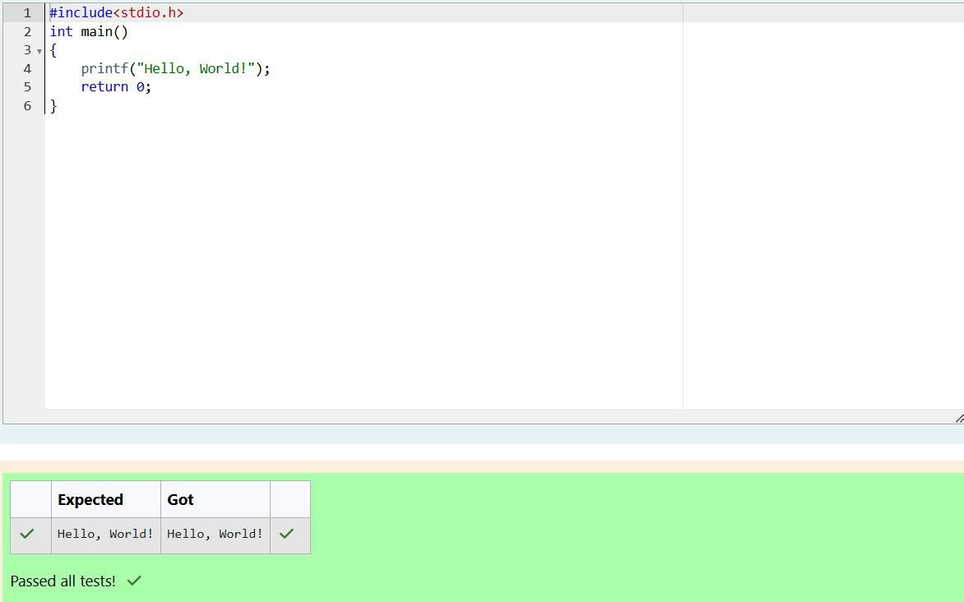

**Program:**

Department of Computer Science and Engineering, Rajalakshmi Engineering College

10

|  |  |
| --- | --- |
| **Ex. No.:** | **Date: 25.9.24** |
| **Playing with Characters** | |
| **Problem Statement:**  This challenge will help you to learn how to take a character, a string and a sentence as input in C. To take a single character **ch** as input, you can use scanf("%c", &ch); and printf("%c", ch) writes a character specified by the argument char to stdout:  char ch; scanf("%c", &ch);  printf("%c", ch);  This piece of code prints the character **ch**. You can take a string as input in C using scanf(“%s”, s). But it accepts string only until it finds the first space.  In order to take a line as input, you can use scanf("%[^\n] %*c", s); where **s** is defined as chars [**MAX_LEN**] where MAX_LEN is the maximum size of **s**. Here, [] is the scanset character. ^\n stands for taking input until a newline isn't encountered. Then, with this  %*c, it reads the newline character and here, the used * indicates that this newline character is discarded.  **Note**: After inputting the character and the string, inputting the sentence by the above mentioned statement won't work. This is because, at the end of each line, a new line character(\n) is present. So, the statement: scanf("%[^\n] %*c", s); will not work because the last statement will read a newline character from the previous line. This can be handled in a variety of ways and one of them being: scanf("\n"); before the last statement. **Task:** You have to print the character, **ch**, in the first line. Then print **s** in next line. In the last line print the sentence, **sen.**  **Input Format**  First, take a character, **ch** as input. Then take the string, **s** as input. Lastly, take the sentence **sen** as input  **Output Format**  Print three lines of output. The first line prints the character, **ch**. The second line prints the string, **s**. The third line prints the sentence, **sen**.  **Sample Input 1**  C  program Programming using C **Sample Output 1**  C  program Programming using C | |

Department of Computer Science and Engineering, Rajalakshmi Engineering College

11

### Program:

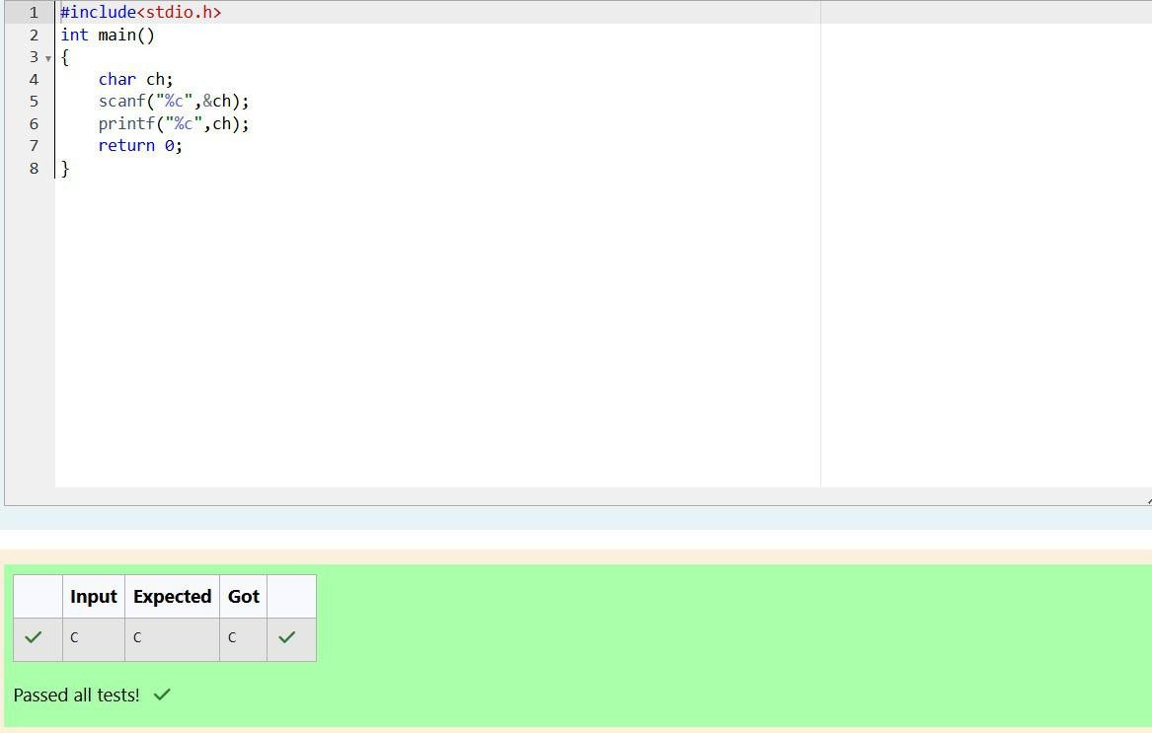

Department of Computer Science and Engineering, Rajalakshmi Engineering College

12

|  |  |
| --- | --- |
| **Ex. No.:** | **Date: 25.9.24** |
| **Sum and Difference of Two Numbers** | |
| **Problem Statement:**  The fundamental data types in c are int, float and char. Today, we're discussing int and float data types.  The printf() function prints the given statement to the console. The syntax is printf("format string",argument_list);. In the function, if we are using an integer, character, string or float as argument, then in the format string we have to write %d (integer), %c (character), %s (string), %f (float) respectively.  The scanf() function reads the input data from the console. The syntax is scanf("format string",argument_list);. For ex: The scanf("%d",&number) statement reads integer number from the console and stores the given value in variable ***number***.  To input two integers separated by a space on a single line, the command is scanf("%d  %d", &n, &m), where ***n*** and ***m*** are the two integers.  **Task**  Your task is to take two numbers of int data type, two numbers of float data type as input and output their sum:   1. Declare ***4*** variables: two of type int and two of type float. 2. Read ***2*** lines of input from stdin (according to the sequence given in the 'Input Format' section below) and initialize your ***4*** variables. 3. Use the ***+*** and ***-*** operator to perform the following operations:    * Print the sum and difference of two int variable on a new line.    * Print the sum and difference of two float variable rounded to one decimal place on a new line.   **Input Format**  The first line contains two integers. The second line contains two floating point numbers.  **Constraints: *1 ≤ integer variables ≤ 104, 1 ≤ float variables ≤ 104***  **Output Format**  Print the sum and difference of both integers separated by a space on the first line, and the sum and difference of both float (scaled to ***1*** decimal place) separated by a space on the second line.  **Sample Input**  10 4  4.0 2.0  **Sample Output**  14 6  6.0 2.0 | |

Department of Computer Science and Engineering, Rajalakshmi Engineering College

13

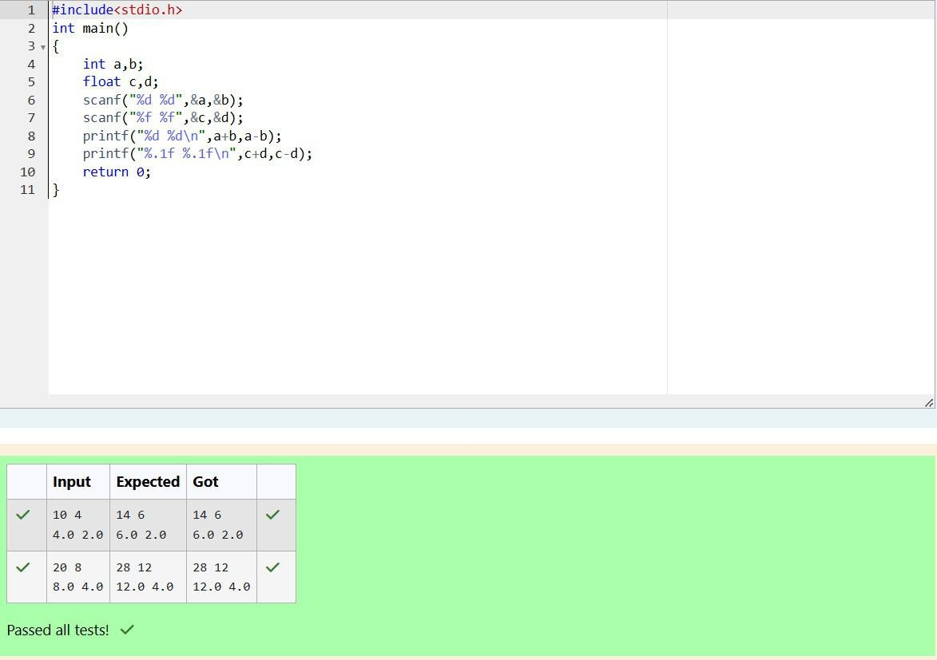

### Program:

Department of Computer Science and Engineering, Rajalakshmi Engineering College

14

|  |  |
| --- | --- |
| **Ex. No.:** | **Date: 25.9.24** |
|  | **Average Marks** |
| **Problem Statement**  Write a program to input a name (as a single character) and marks of three tests as m1, m2, and m3 of a student considering all the three marks have been given in integer format.  Now, you need to calculate the average of the given marks and print it along with the name as mentioned in the output format section.  All the test marks are in integers and hence calculate the average in integer as well. That is, you need to print the integer part of the average only and neglect the decimal part.  **Input Format :**  Line 1 : Name(Single character)  Line 2 : Marks scored in the 3 tests separated by single space.  **Output Format:**  First line of output prints the name of the student. Second line of the output prints the average mark.  **Constraints**  Marks for each student lie in the range 0 to 100 (both inclusive)  **Sample Input 1 :**  A  3 4 6  **Sample Output 1 :**  A 4 | |

Department of Computer Science and Engineering, Rajalakshmi Engineering College

15

### Program:

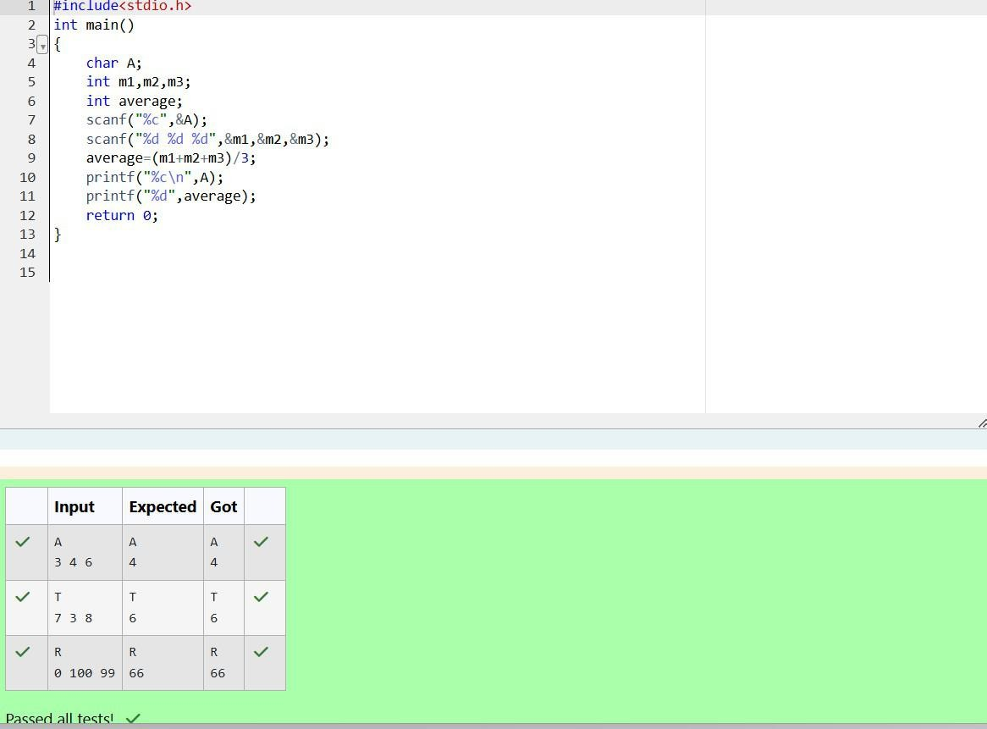

Department of Computer Science and Engineering, Rajalakshmi Engineering College

16

|  |  |
| --- | --- |
| **Ex. No.:** | **Date: 25.9.24** |
| **Basic Data Types** | |
| **Problem Statement:**  Some *C* data types, their format specifiers, and their most common bit widths are as follows:   * *Int ("%d"):* 32 Bit integer * *Long ("%ld"):* 64 bit integer * *Char ("%c"):* Character type * *Float ("%f"):* 32 bit real value * *Double ("%lf"):* 64 bit real value   **Reading**  To read a data type, use the following syntax: scanf("`format_specifier`", &val) For example, to read a *character* followed by a *double*: char ch;  double d;  scanf("%c %lf", &ch, &d);  For the moment, we can ignore the spacing between format specifiers.  **Printing**  To print a data type, use the following syntax: printf("`format_specifier`", val) For example, to print a *character* followed by a *double*: char ch = 'd';  double d = 234.432; printf("%c %lf", ch, d);  **Note:** You can also use *cin* and *cout* instead of *scanf* and *printf*; however, if you are taking a million numbers as input and printing a million lines, it is faster to use *scanf* and *printf*.  **Input Format**  Input consists of the following space-separated values: *int*, *long*, *char*, *float*, and *double*, respectively.  **Output Format**  Print each element on a new line in the same order it was received as input. Note that the floating-point value should be correct up to 3 decimal places and the double to 9 decimal places.  **Sample Input**  3  12345678912345  a 334.23  14049.30493  **Sample Output**  3  12345678912345  a 334.230  14049.304930000 | |

Department of Computer Science and Engineering, Rajalakshmi Engineering College

17

### Program:

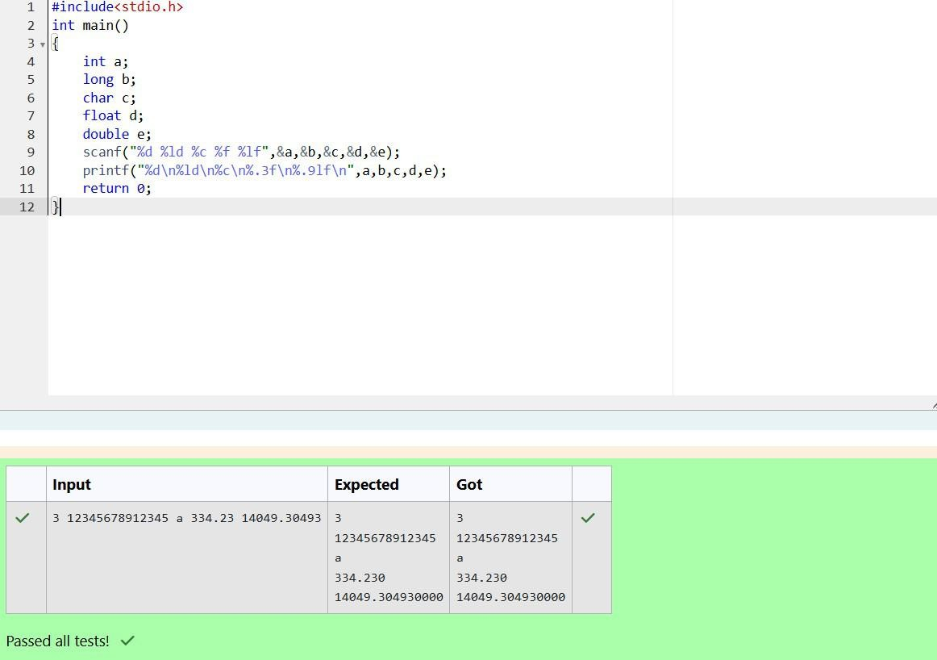

Department of Computer Science and Engineering, Rajalakshmi Engineering College

18

|  |  |
| --- | --- |
| **Ex. No.:** | **Date: 25.9.24** |
| **ASCII Value and Adjacent Characters** | |
| **Problem Statement:**  Write a program to print the ASCII value and the two adjacent characters of the given character.  **Input Format:** Reads the character  **Output Format:** First line prints the ascii value, second line prints the previous character and next character of the input character  **Sample Input 1:**  E  **Sample Output 1:**  69  D F | |

Department of Computer Science and Engineering, Rajalakshmi Engineering College

19

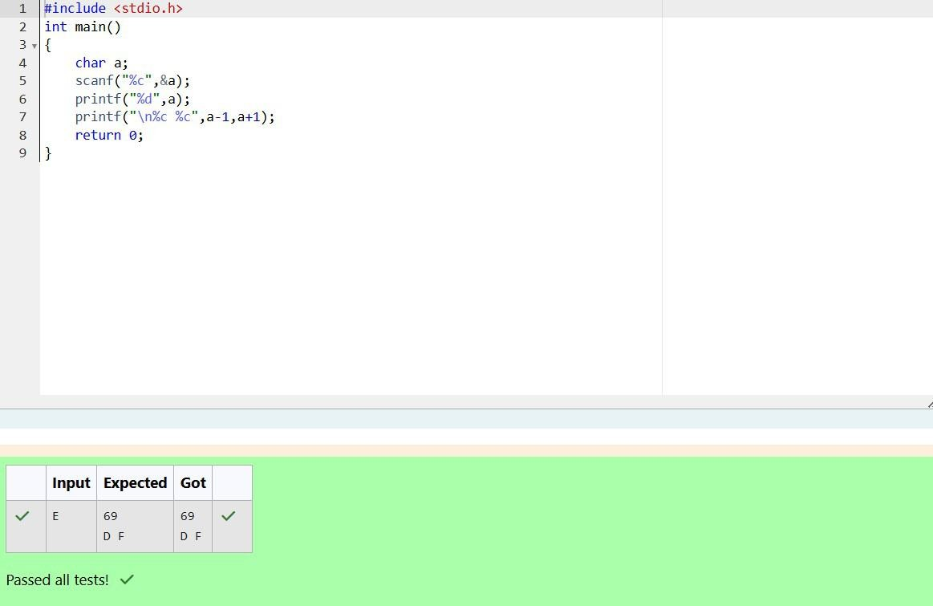

### Program:

Department of Computer Science and Engineering, Rajalakshmi Engineering College

20

**Operators and Expressions, Managing Input and Output Operations**

Department of Computer Science and Engineering, Rajalakshmi Engineering College

21

|  |  |
| --- | --- |
| **Ex. No.:** | **Date:9.10.24** |
|  | **Height Units** |
| **Problem Statement:**  Many people think about their height in feet and inches, even in some countries that primarily use the metric system. Write a program that reads a number of feet from the user, followed by a number of inches. Once these values are read, your program should compute and display the equivalent number of centimeters.  **Hint**: One foot is 12 inches. One inch is 2.54 centimeters.  **Input Format**  First line, read the number of feet. Second line, read the number of inches. **Output Format**  In one line print the height in centimeters.  Note: All of the values should be displayed using two decimal places.  **Sample Input 1**  5  6  **Sample Output 1**  167.64 | |

Department of Computer Science and Engineering, Rajalakshmi Engineering College

22

### Program:

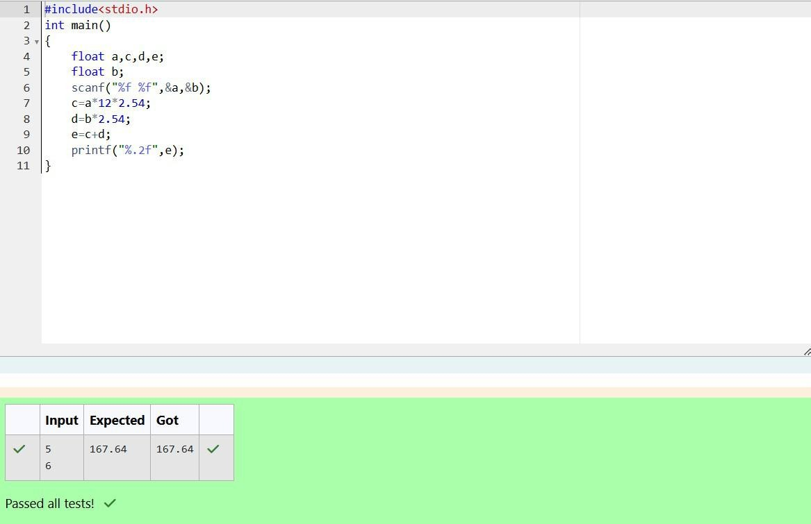

Department of Computer Science and Engineering, Rajalakshmi Engineering College

23

|  |  |
| --- | --- |
| **Ex. No.:** | **Date: 9.10.24** |
|  | **Arithmetic** |
| **Problem Statement:**  Create a program that reads two integers, a and b, from the user. Your program should compute and display:   * The sum of a and b * The difference when b is subtracted from a * The product of a and b * The quotient when a is divided by b * The remainder when a is divided by b   **Input Format**  First line, read the first number. Second line, read the second number.  **Output Format**  First line, print the sum of a and b  Second line, print the difference when b is subtracted from a Third line, print the product of a and b  Fourth line, print the quotient when a is divided by b Fifth line, print the remainder when a is divided by b  **Sample Input 1**  100  6  **Sample Output1**  106  94  600  16  4 | |

Department of Computer Science and Engineering, Rajalakshmi Engineering College

24

### Program:

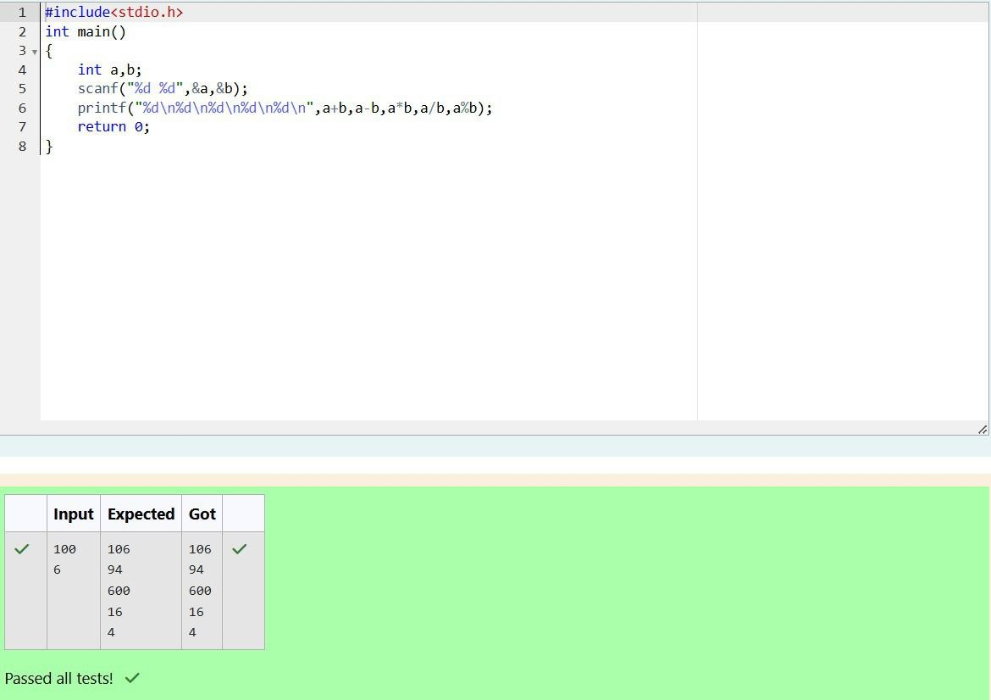

Department of Computer Science and Engineering, Rajalakshmi Engineering College

25

|  |  |
| --- | --- |
| **Ex. No.:** | **Date: 9.10.24** |
| **Day Old Bread** | |
| **Problem Statement:**  A bakery sells loaves of bread for $3.49 each. Day old bread is discounted by 60 percent. Write a program that begins by reading the number of loaves of day-old bread being purchased from the user. Then your program should display the regular price for the bread, the discount because it is a day old, and the total price. Each of these amounts should be displayed on its own line with an appropriate label. All of the values should be displayed using two decimal places.  **Input Format**  Read the number of day old loaves.  **Output Format**  First line, print Regular price: price Second line, print Discount: discount Third line, print Total: total  **Note**: All of the values should be displayed using two decimal places.  **Sample Input 1**  10  **Sample Output 1**  Regular price: 34.90 Discount: 20.94 Total: 13.96 | |

Department of Computer Science and Engineering, Rajalakshmi Engineering College

26

### Program:

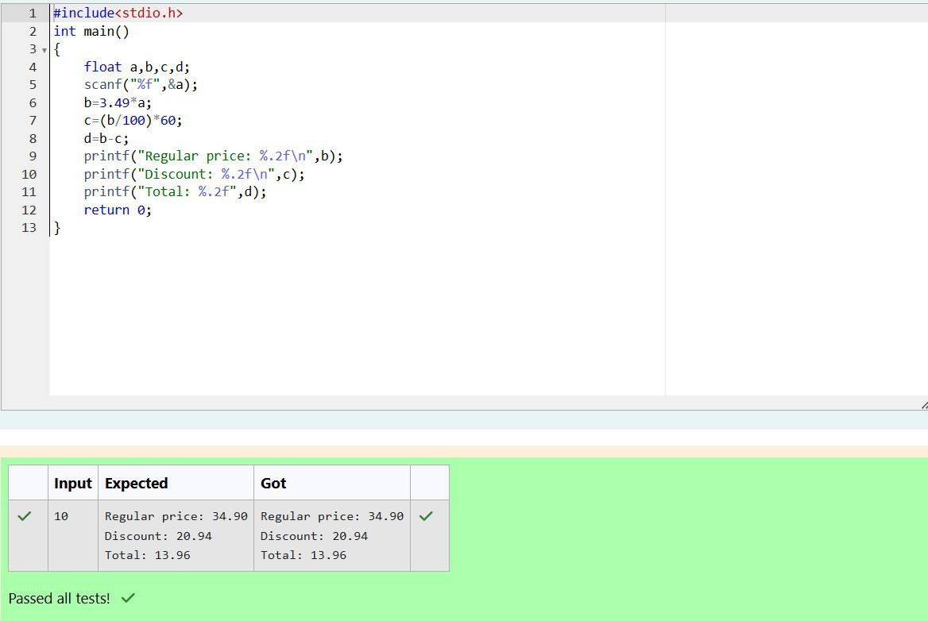

Department of Computer Science and Engineering, Rajalakshmi Engineering College

27

|  |  |
| --- | --- |
| **Ex. No. :** | **Date : 9.10.24** |
|  | **Goki and his Breakup** |
| **Problem Statement:**  Goki recently had a breakup, so he wants to have some more friends in his life. Goki has **N** people who he can be friends with, so he decides to choose among them according to their skills set **Yi**(1<=i<=n). He wants atleast **X** skills in his friends.  Help Goki find his friends.  **Input Format**  First line contains a single integer **X** - denoting the minimum skill required to be Goki's friend. Next line contains one integer **Y** - denoting the skill of the person.  **Output Format**  Print if he can be friend with Goki. '**YES' (without quotes)** if he can be friends with Goki else '**NO' (without quotes)**.  **Constraints**  **1<=N<=1000000 1<=X,Y<=1000000**  **SAMPLE INPUT 1**  100  110  **SAMPLE OUTPUT 1**  YES | |

Department of Computer Science and Engineering, Rajalakshmi Engineering College

28

### Program:

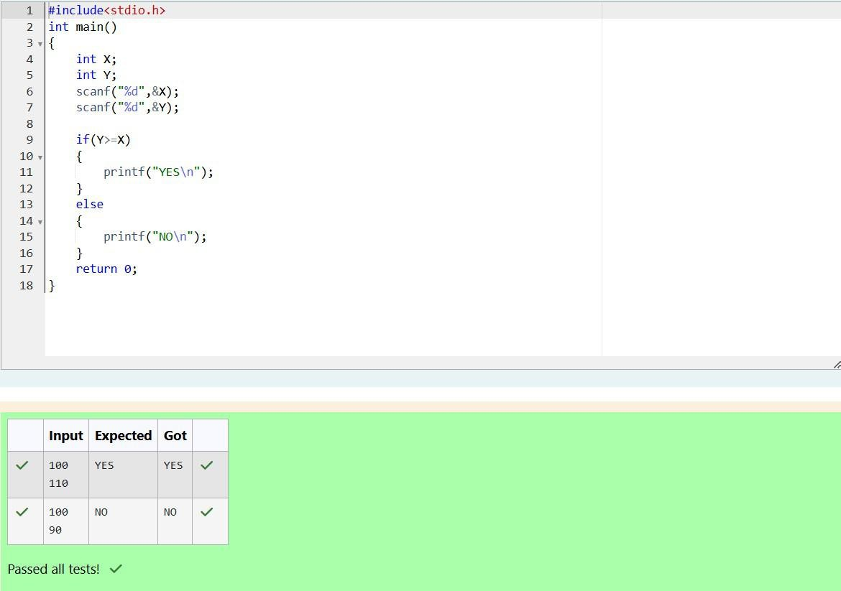

Department of Computer Science and Engineering, Rajalakshmi Engineering College

29

|  |  |
| --- | --- |
| **Ex. No. :** | **Date : 9.10.24** |
|  | **Say no to Handshakes!!!** |
| **Problem Statement:**  Before the outbreak of corona virus to the world, a meeting happened in a room in Wuhan. A person who attended that meeting had COVID-19 and no one in the room knew about it! So, everyone started shaking hands with everyone else in the room as a gesture of respect and after meeting unfortunately everyone got infected! Given the fact that any two persons shake hand exactly once, can you tell the total count of handshakes happened in that meeting?  ***Say no to shakehands. Regularly wash your hands. Stay Safe.***  **Input Format**  Read an integer N, the total number of people attended that meeting.  **Output Format**  Print the number of handshakes.  **Constraints**  0 < N < 106  **SAMPLE INPUT 1**  1  **SAMPLE OUTPUT**  0 | |

Department of Computer Science and Engineering, Rajalakshmi Engineering College

30

### Program:

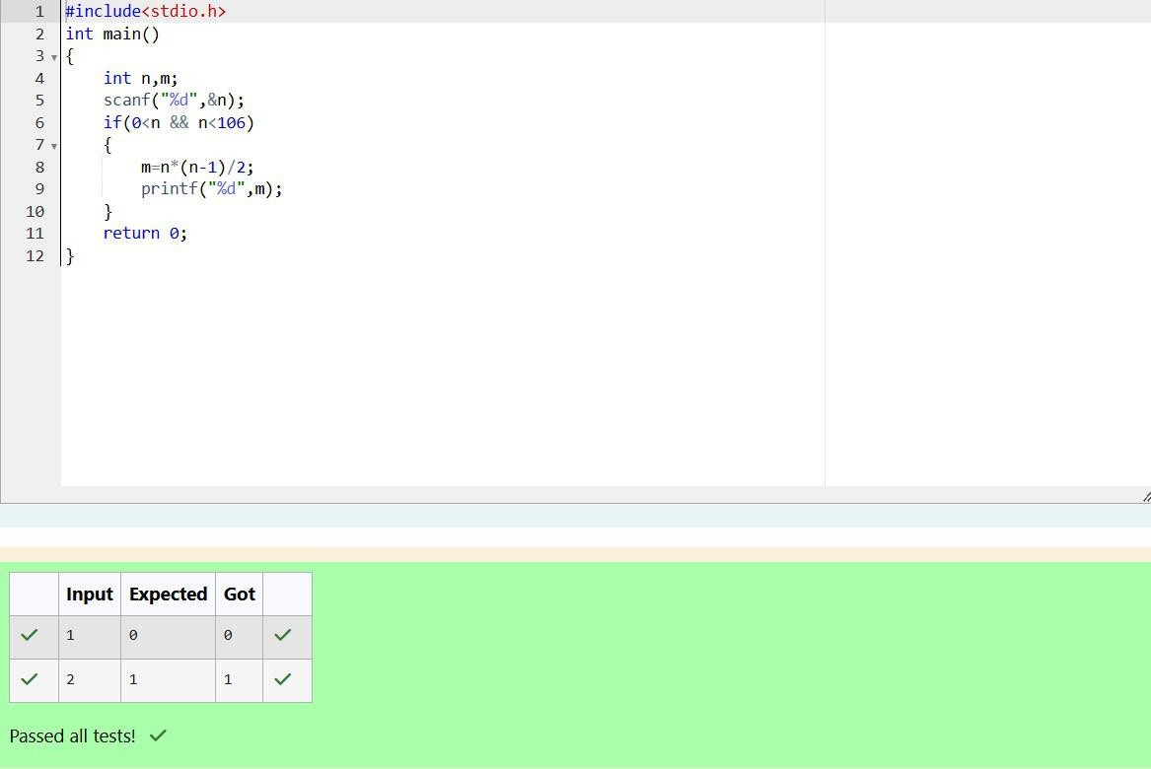

Department of Computer Science and Engineering, Rajalakshmi Engineering College

31

|  |  |
| --- | --- |
| **Ex. No. :** | **Date : 9.10.24** |
|  | **Back to School** |
| **Problem Statement:**  In our school days, all of us have enjoyed the Games period. Raghav loves to play cricket and is Captain of his team. He always wanted to win all cricket matches. But only one last Games period is left in school now. After that he will pass out from school.  So, this match is very important to him. He does not want to lose it. So he has done a lot of planning to make sure his teams wins. He is worried about only one opponent - Jatin, who is very good batsman.  Raghav has figured out 3 types of bowling techniques, that could be most beneficial for dismissing Jatin. He has given points to each of the 3 techniques.  You need to tell him which is the maximum point value, so that Raghav can select best technique.  3 numbers are given in input. Output the maximum of these numbers.  **Input Format:**  Three space separated integers.  **Output Format:**  Maximum integer value  **SAMPLE INPUT**  8 6 1  **SAMPLE OUTPUT**  8 | |

Department of Computer Science and Engineering, Rajalakshmi Engineering College

32

### Program:

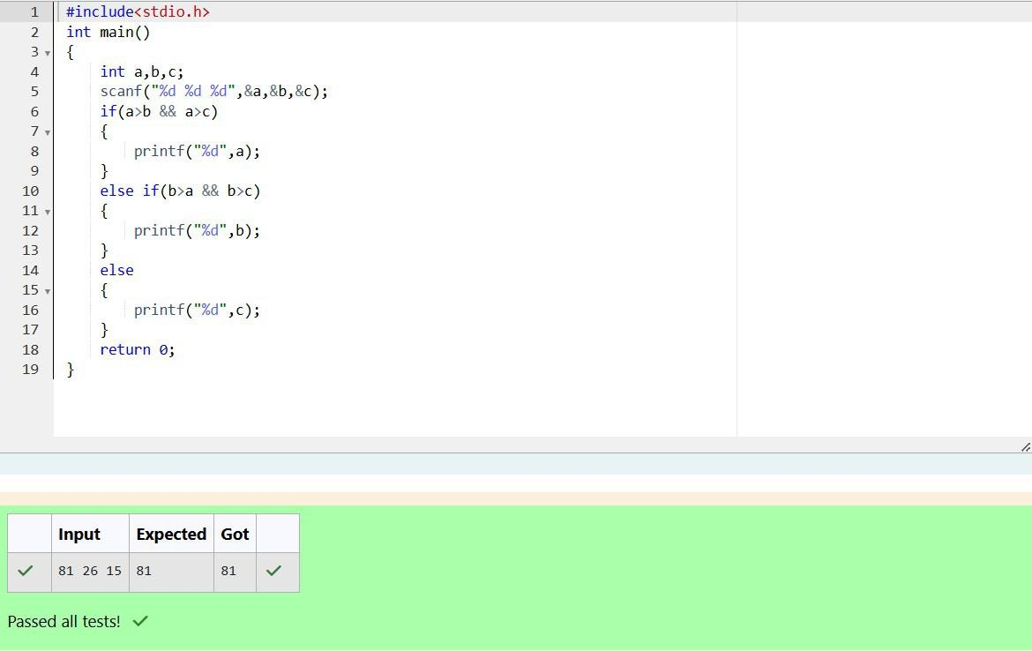

Department of Computer Science and Engineering, Rajalakshmi Engineering College

33

**Decision Making and Branching – if, if...else, nested if…else, if…else if,**

**Switch-Case**

Department of Computer Science and Engineering, Rajalakshmi Engineering College

34

|  |  |
| --- | --- |
| **Ex. No. :** | **Date :18.10.24** |
|  | **Same Digit** |
| **Problem Statement:**  Write a program to read two integer values and print true if both the numbers end with the same digit, otherwise print false.  Example: If 698 and 768 are given, program should print true as they both end with 8.  **Sample Input 1**  25 53  **Sample Output 1**  false  **Sample Input 2**  27 77  **Sample Output 2**  true | |

Department of Computer Science and Engineering, Rajalakshmi Engineering College

35

### Program:

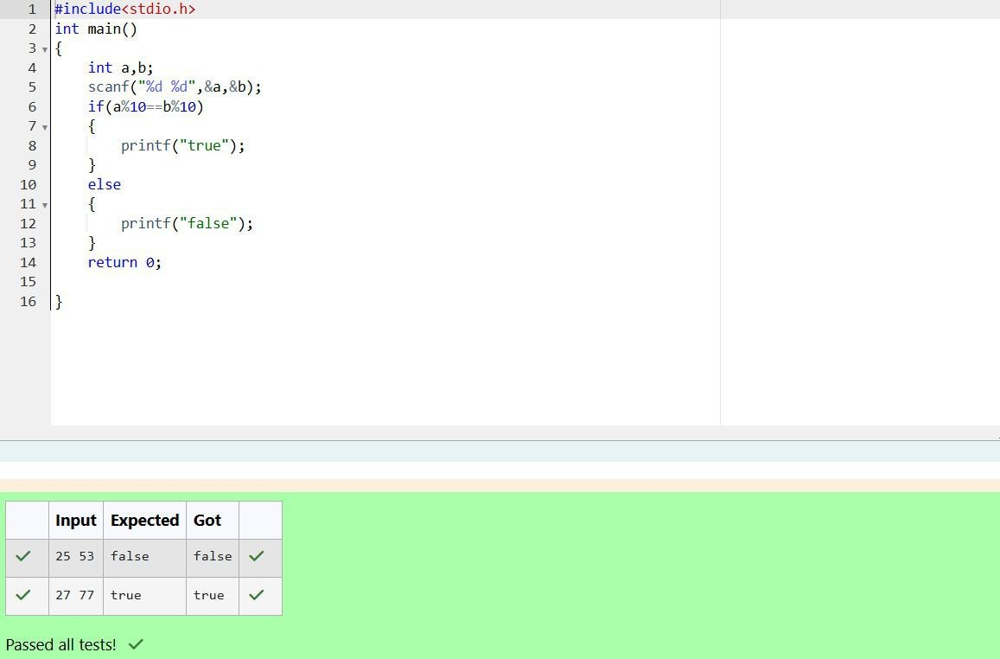

Department of Computer Science and Engineering, Rajalakshmi Engineering College

36

|  |  |
| --- | --- |
| **Ex. No. :** | **Date : 18.10.24** |
| **Intro to Conditional Statements** | |
| **Problem Statement:**  In this challenge, we're getting started with conditional statements.  **Task**  Given an integer, ***n***, perform the following conditional actions:   * If ***n*** is odd, print Weird * If ***n*** is even and in the inclusive range of ***2*** to ***5***, print ***Not Weird*** * If ***n*** is even and in the inclusive range of ***6*** to ***20***, print ***Weird*** * If ***n*** is even and greater than ***20***, print ***Not Weird***   Complete the stub code provided in your editor to print whether or not ***n*** is weird.  **Input Format**  A single line containing a positive integer, ***n***.  **Constraints**   * 1 < n < 100   **Output Format**  Print Weird if the number is weird; otherwise, print Not Weird.  **Sample Input 0**  3  **Sample Output 0**  Weird | |

Department of Computer Science and Engineering, Rajalakshmi Engineering College

37

### Program:

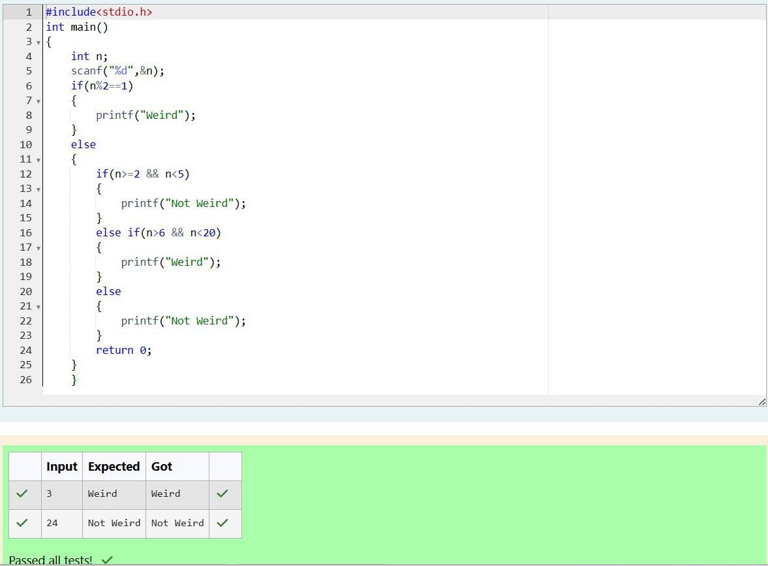

Department of Computer Science and Engineering, Rajalakshmi Engineering College

38

|  |  |
| --- | --- |
| **Ex. No. :** | **Date : 18.10.24** |
|  | **Pythagorean Triples** |
| **Problem Statement:**  Three numbers form a Pythagorean triple if the sum of squares of two numbers is equal to the square of the third.  For example, 3, 5 and 4 form a Pythagorean triple, since 3*3 + 4*4 = 25 = 5*5  You are given three integers, a, b, and c. They need not be given in increasing order. If they form a Pythagorean triple, then print "yes", otherwise, print "no". Please note that the output message is in small letters.  **Sample Input 1**  3  5  4  **Sample Output 1**  yes | |

Department of Computer Science and Engineering, Rajalakshmi Engineering College

39

### Program:

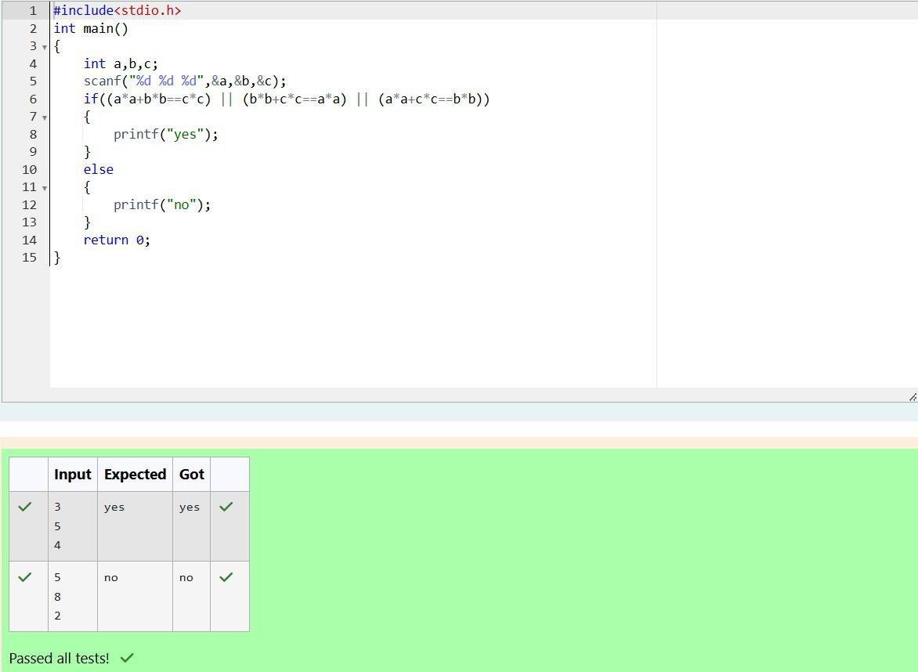

Department of Computer Science and Engineering, Rajalakshmi Engineering College

40

|  |  |
| --- | --- |
| **Ex. No. :** | **Date : 18.10.24** |
|  | **Name That Shape** |
| **Problem Statement:**  Write a program that determines the name of a shape from its number of sides. Read the number of sides from the user and then report the appropriate name as part of a meaningful message. Your program should support shapes with anywhere from 3 up to (and including) 10 sides. If a number of sides outside of this range is entered then your program should display an appropriate error message.  **Sample Input 1**  3  **Sample Output 1**  Triangle  **Sample Input 2**  7  **Sample Output 2**  Heptagon  **Sample Input 3**  11  **Sample Output 3**  The number of sides is not supported. | |

Department of Computer Science and Engineering, Rajalakshmi Engineering College

41

### Program:

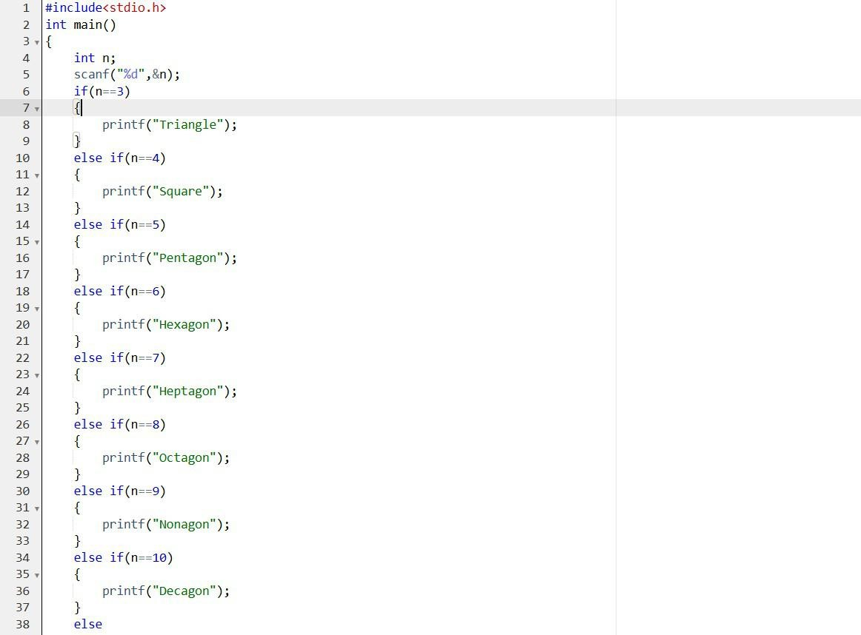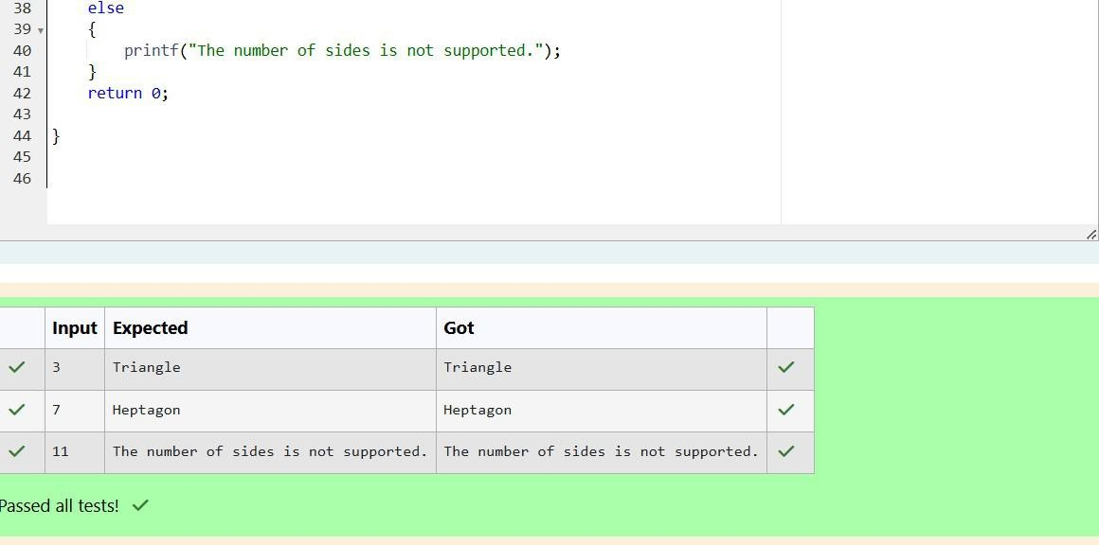

Department of Computer Science and Engineering, Rajalakshmi Engineering College

42

|  |  |
| --- | --- |
| **Ex. No. :** | **Date :23.10.24** |
|  | **Chinese Zodiac** |
| **Problem Statement:**  The Chinese zodiac assigns animals to years in a 12-year cycle. One 12-year cycle is shown in the table below. The pattern repeats from there, with 2012 being another year of the Dragon, and 1999 being another year of the Hare.  **Year Animal**  2000 Dragon  2001 Snake  2002 Horse  2003 Sheep  2004 Monkey  2005 Rooster  2006 Dog  2007 Pig  2008 Rat  2009 Ox  2010 Tiger  2011 Hare  Write a program that reads a year from the user and displays the animal associated with that year. Your program should work correctly for any year greater than or equal to zero, not just the ones listed in the table.  **Sample Input 1**  2004  **Sample Output 1**  Monkey  **Sample Input 2**  2010  **Sample Output 2**  Tiger | |

Department of Computer Science and Engineering, Rajalakshmi Engineering College

43

|  |
| --- |
| **Program:** |

Department of Computer Science and Engineering, Rajalakshmi Engineering College

44

|  |  |
| --- | --- |
| **Ex. No. :** | **Date : 23.10.24** |
|  | **What Color Is That Square?** |
| **Problem Statement:**  Positions on a chess board are identified by a letter and a number. The letter identifies the column, while the number identifies the row, as shown below:    Write a program that reads a position from the user. Use an if statement to determine if the column begins with a black square or a white square. Then use modular arithmetic to report the color of the square in that row. For example, if the user enters a1 then your program should report that the square is black. If the user enters d5 then your program should report that the square is white. Your program may assume that a valid position will always be entered. It does not need to perform any error checking.  **Sample Input 1**  a 1  **Sample Output 1**  The square is black.  **Sample Input 2**  d 5  **Sample Output 2**  The square is white. | |

Department of Computer Science and Engineering, Rajalakshmi Engineering College

45

|  |
| --- |
| **Program:** |

Department of Computer Science and Engineering, Rajalakshmi Engineering College

46

|  |  |
| --- | --- |
| **Ex. No. :** | **Date : 23.10.24** |
|  | **Day of Year** |
| **Problem Statement:**  Some data sets specify dates using the year and day of year rather than the year, month, and day of month. The day of year (DOY) is the sequential day number starting with day 1 on January 1st.  There are two calendars - one for normal years with 365 days, and one for leap years with 366 days. Leap years are divisible by 4. Centuries, like 1900, are not leap years unless they are divisible by 400. So, 2000 was a leap year.  To find the day of year number for a standard date, scan down the Jan column to find the day of month, then scan across to the appropriate month column and read the day of year number. Reverse the process to find the standard date for a given day of year.  Write a program to print the Day of Year of a given date, month and year.  Sample Input 1  18  6  2020  Sample Output 1  170 | |

Department of Computer Science and Engineering, Rajalakshmi Engineering College

47

### Program:

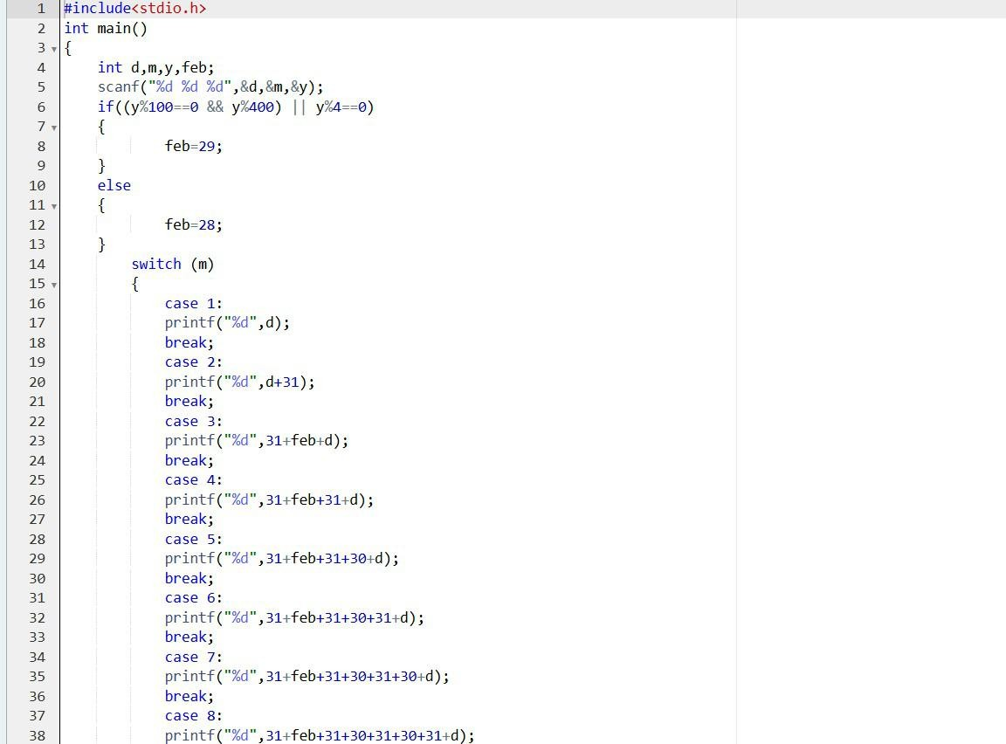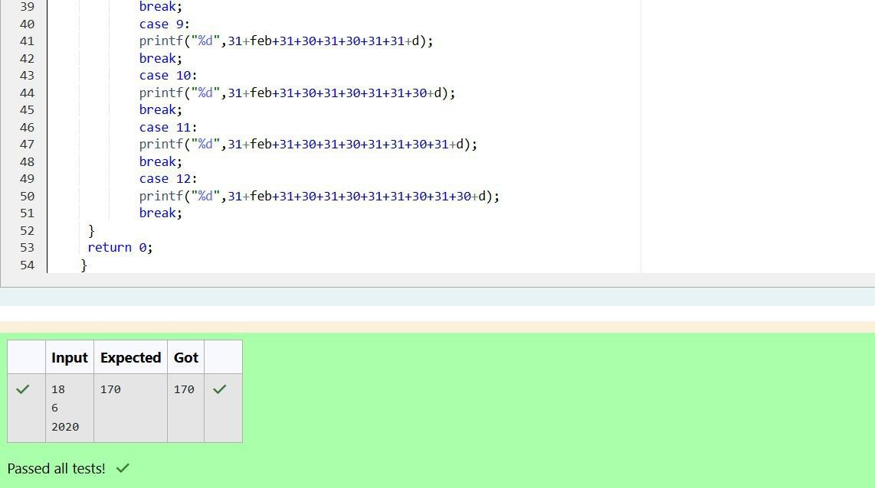

Department of Computer Science and Engineering, Rajalakshmi Engineering College

48

|  |  |
| --- | --- |
| **Ex. No. :** | **Date : 23.10.24** |
|  | **Suppandi & Areas** |
| **Problem Statement:**  Suppandi is trying to take part in the local village math quiz. In the first round, he is asked about shapes and areas. Suppandi, is confused, he was never any good at math. And also, he is bad at remembering the names of shapes. Instead, you will be helping him calculate the area of shapes.   * When he says rectangle, he is actually referring to a square. * When he says square, he is actually referring to a triangle. * When he says triangle, he is referring to a rectangle * And when he is confused, he just says something random. At this point, all you can do is say 0.   Help Suppandi by printing the correct answer in an integer.  **Input Format**   * Name of shape (always in upper case R **-->** Rectangle, S -**->** Square, T **-->** Triangle) * Length of 1 side * Length of other side   **Note**: In case of triangle, you can consider the sides as height and length of base  **Output Format**   * Print the area of the shape.   **Sample Input 1**  T 10  20  **Sample Output 1**  200 | |

Department of Computer Science and Engineering, Rajalakshmi Engineering College

49

|  |
| --- |
| **Program:** |

Department of Computer Science and Engineering, Rajalakshmi Engineering College

50

|  |  |
| --- | --- |
| **Ex. No. :** | **Date : 23.10.24** |
|  | **Superman's Encounter** |
| **Problem Statement:**  Superman is planning a journey to his home planet. It is very important for him to know which day he arrives there. They don't follow the 7-day week like us. Instead, they follow a 10-day week with the following days:  **Day Number Name of Day**   1. Sunday 2. Monday 3. Tuesday 4. Wednesday 5. Thursday 6. Friday 7. Saturday 8. Kryptonday 9. Coluday 10. Daxamday   Here are the rules of the calendar:   * The calendar starts with Sunday always. * It has only 296 days. After the 296th day, it goes back to Sunday.   You begin your journey on a Sunday and will reach after n. You have to tell on which day you will arrive when you reach there.  **Input format:**   * Contain a number n (0 < n)   **Output format:**  Print the name of the day you are arriving on  **Sample Input**  7  **Sample Output**  Kryptonday  **Sample Input**  1  **Sample Output**  Monday | |

Department of Computer Science and Engineering, Rajalakshmi Engineering College

51

|  |
| --- |
| **Program:** |

Department of Computer Science and Engineering, Rajalakshmi Engineering College

52

**Decision Making and Looping – while and do…while, for**

Department of Computer Science and Engineering, Rajalakshmi Engineering College

53

|  |  |
| --- | --- |
| **Ex. No. :** | **Date :25.10.24** |
|  | **Stone Game-One Four** |
| **Problem Statement:**  Alice and Bob are playing a game called "Stone Game". Stone game is a two-player game. Let N be the total number of stones. In each turn, a player can remove either one stone or four stones. The player who picks the last stone, wins. They follow the "Ladies First" norm. Hence Alice is always the one to make the first move. Your task is to find out whether Alice can win, if both play the game optimally.  **Input Format**  First line starts with T, which is the number of test cases. Each test case will contain N number of stones.  **Output Format**  Print "Yes" in the case Alice wins, else print "No".  **Constraints** 1<=T<=1000 1<=N<=10000  **Sample Input**  3  1  6  7  **Sample Output**  Yes Yes No | |

Department of Computer Science and Engineering, Rajalakshmi Engineering College

54

### Program:

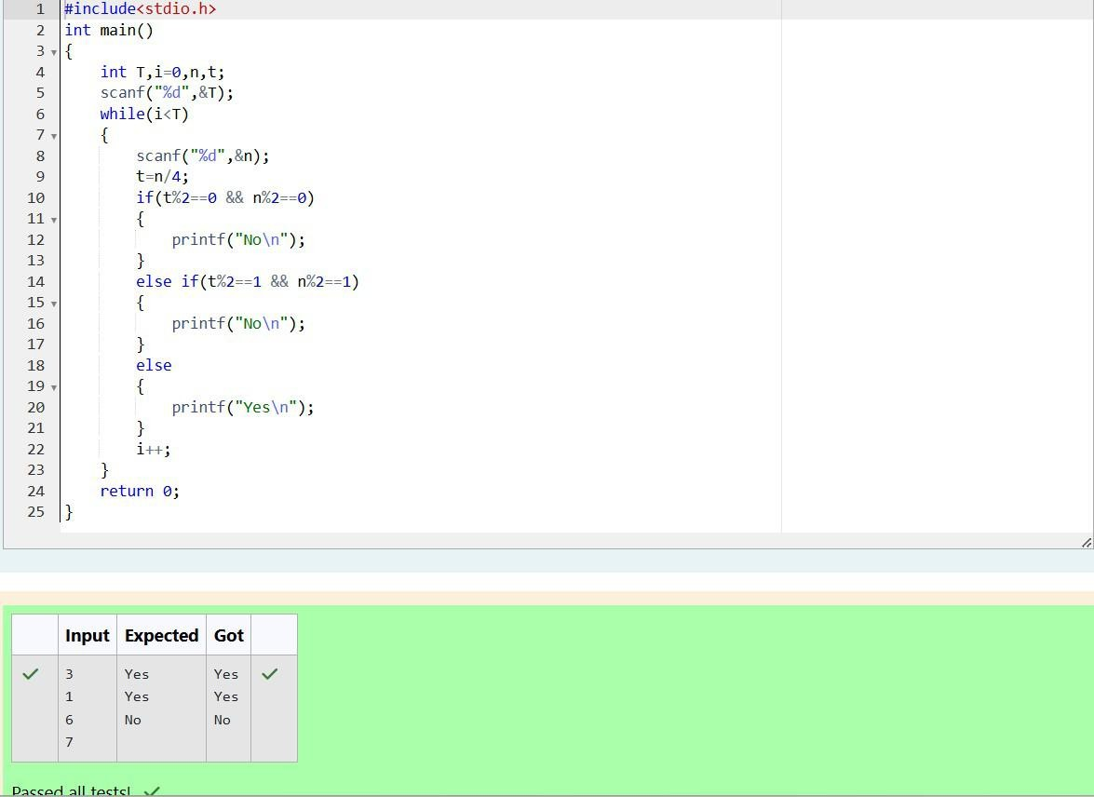

Department of Computer Science and Engineering, Rajalakshmi Engineering College

55

|  |  |
| --- | --- |
| **Ex. No. :** | **Date : 25.10.24** |
|  | **Holes in a Number** |
| **Problem Statement:**  You are designing a poster which prints out numbers with a unique style applied to each of them. The styling is based on the number of closed paths or holes present in a given number.  The number of holes that each of the digits from 0 to 9 have are equal to the number of closed paths in the digit. Their values are:  1, 2, 3, 5, 7 = 0 holes.  0, 4, 6, 9 = 1 hole.  8 = 2 holes.  Given a number, you must determine the sum of the number of holes for all of its digits. For example, the number 819 has 3 holes.  Complete the program, it must return an integer denoting the total number of holes in num.  **Constraints**  1 ≤ num ≤ 109  **Input Format For Custom Testing**  There is one line of text containing a single integer num, the value to process.  **Sample Input**  630  **Sample Output**  2 | |

Department of Computer Science and Engineering, Rajalakshmi Engineering College

56

### Program:

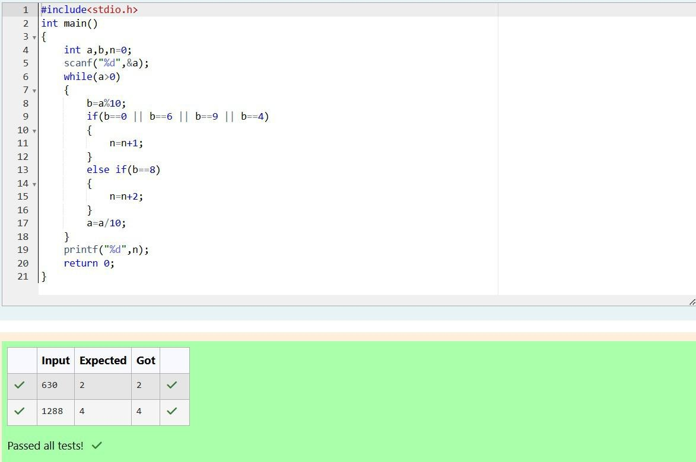

Department of Computer Science and Engineering, Rajalakshmi Engineering College

57

|  |  |
| --- | --- |
| **Ex. No. :** | **Date : 25.10.24** |
|  | **Philaland Coin** |
| **Problem Statement:**  The problem solvers have found a new Island for coding and named it as Philaland. These smart people were given a task to make a purchase of items at the Island easier by distributing various coins with different values. Manish has come up with a solution that if we make coins category starting from $1 till the maximum price of the item present on Island, then we can purchase any item easily. He added the following example to prove his point.  Let’s suppose the maximum price of an item is 5$ then we can make coins of {$1, $2, $3,  $4, $5}to purchase any item ranging from $1 till $5.  Now Manisha, being a keen observer suggested that we could actually minimize the number of coins required and gave following distribution {$1, $2, $3}. According to him any item can be purchased one time ranging from $1 to $5. Everyone was impressed with both of them. Your task is to help Manisha come up with a minimum number of denominations for any arbitrary max price in Philaland.  **Input Format**  Contains an integer N denoting the maximum price of the item present on Philaland.  **Output Format**  Print a single line denoting the minimum number of denominations of coins required.  **Constraints**  1<=T<=100 1<=N<=5000  **Sample Input 1:**  10  **Sample Output 1:**  4 | |

Department of Computer Science and Engineering, Rajalakshmi Engineering College

58

|  |
| --- |
| **Program:** |

Department of Computer Science and Engineering, Rajalakshmi Engineering College

59

|  |  |
| --- | --- |
| **Ex. No. :** | **Date :6.11.24** |
|  | **Number Count** |
| **Problem Statement:**  A set of N numbers (separated by one space) is passed as input to the program. The program must identify the count of numbers where the number is odd number.  **Input Format:**  The first line will contain the N numbers separated by one space.  **Boundary Conditions:**  3 <= N <= 50  The value of the numbers can be from -99999999 to 99999999  **Output Format:**  The count of numbers where the numbers are odd numbers.  **Sample Input:**  5 10 15 20 25 30 35 40 45 50  **Sample Output:**  5 | |

Department of Computer Science and Engineering, Rajalakshmi Engineering College

60

### Program:

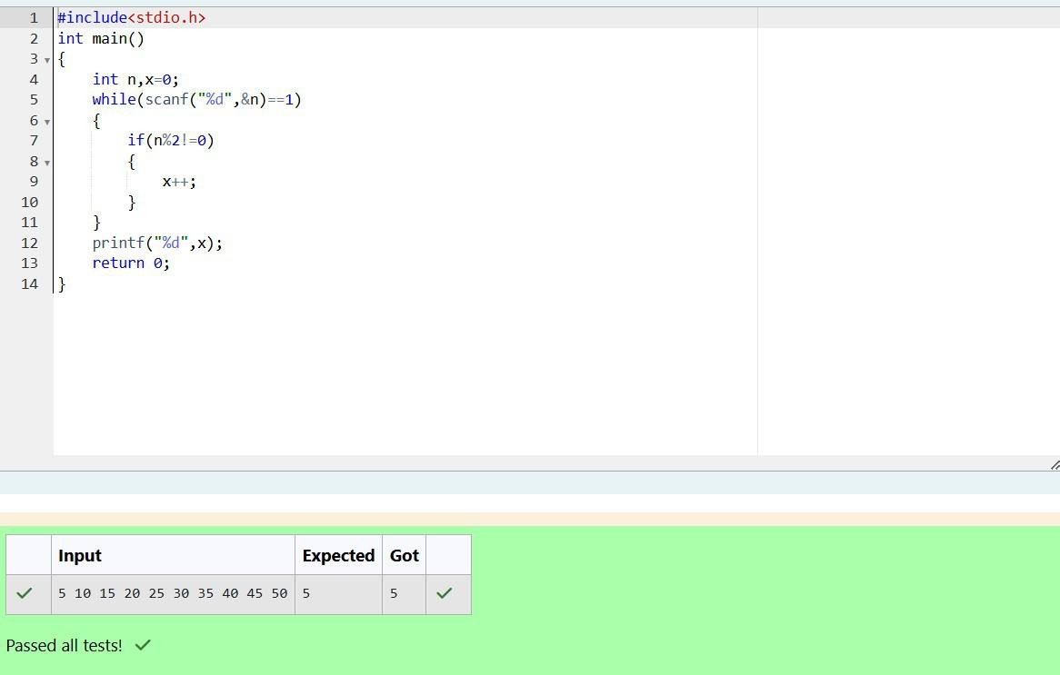

Department of Computer Science and Engineering, Rajalakshmi Engineering College

61

|  |  |
| --- | --- |
| **Ex. No. :** | **Date : 6.11.24** |
|  | **Confusing Number** |
| **Problem Statement:**  Given a number N, return true if and only if it is a *confusing number*, which satisfies the following condition:  We can rotate digits by 180 degrees to form new digits. When 0, 1, 6, 8, 9 are rotated 180  degrees, they become 0, 1, 9, 8, 6 respectively. When 2, 3, 4, 5 and 7 are rotated 180 degrees, they become invalid. A *confusing number* is a number that when rotated 180 degrees becomes a **different** number with each digit valid.  **Example 1:**    Input: 6 Output: true  Explanation: We get 9 after rotating 6, 9 is a valid number and 9 != 6.  **Example 2:**    Input: 89 Output: true  Explanation: We get 68 after rotating 89, 86 is a valid number and 86 != 89.  **Example 3:**    Input: 11 Output: false  Explanation: We get 11 after rotating 11, 11 is a valid number but the value remains the same, thus 11 is not a confusing number.  **Example 4:**    Input: 25 Output: false  Explanation: We get an invalid number after rotating 25.  **Note:**   1. 0 <= N <= 10^9 2. After the rotation we can ignore leading zeros, for example if after rotation we have 0008 then this number is considered as just 8. | |

Department of Computer Science and Engineering, Rajalakshmi Engineering College

62

### Program:

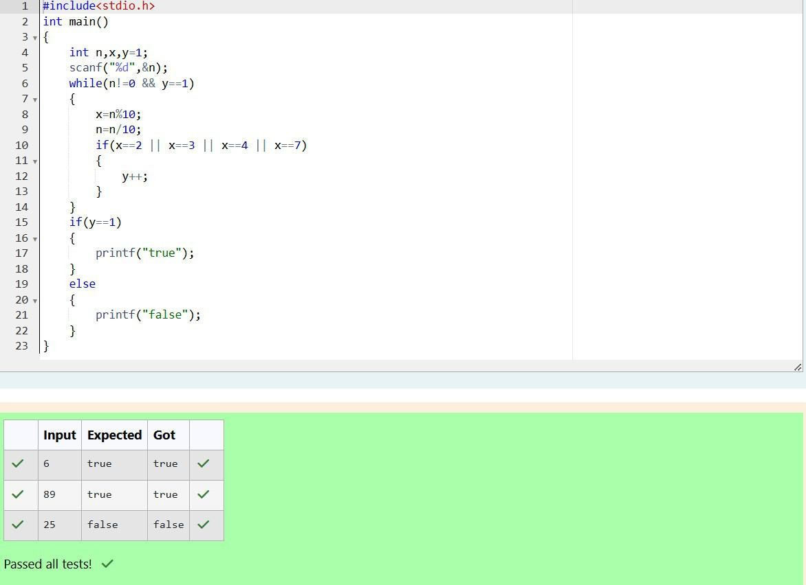

Department of Computer Science and Engineering, Rajalakshmi Engineering College

63

|  |  |
| --- | --- |
| **Ex. No. :** | **Date : 6.11.24** |
|  | **Nutrition Value** |
| **Problem Statement:**  A nutritionist is labeling all the best power foods in the market. Every food item arranged in a single line, will have a value beginning from 1 and increasing by 1 for each, until all items have a value associated with them. An item's value is the same as the number of macronutrients it has. For example, food item with value 1 has 1 macronutrient, food item with value 2 has 2 macronutrients, and incrementing in this fashion.  The nutritionist has to recommend the best combination to patients, i.e. maximum total of macronutrients. However, the nutritionist must avoid prescribing a particular sum of macronutrients (an 'unhealthy' number), and this sum is known. The nutritionist chooses food items in the increasing order of their value. Compute the highest total of macronutrients that can be prescribed to a patient, without the sum matching the given 'unhealthy' number.  Here's an illustration: Given *4* food items (hence value: *1,2,3* and *4*), and the unhealthy sum being *6* macronutrients, on choosing items *1, 2, 3* -> the sum is *6,* which matches the 'unhealthy' sum. Hence, one of the three needs to be skipped. Thus, the best combination is from among:   * *2 + 3 + 4 = 9* * *1 + 3 + 4 = 8* * *1 + 2 + 4 = 7*   Since *2 + 3 + 4 = 9,* allows for maximum number of macronutrients, 9 is the right answer. Complete the code in the editor below. It must return an integer that represents the maximum total of macronutrients, modulo *1000000007 (109 + 7)*.  It has the following:  *n:* an integer that denotes the number of food items  *k:* an integer that denotes the unhealthy number  **Constraints**   * *1 ≤ n ≤ 2 × 109* * *1 ≤ k ≤ 4 × 1015*   **Input Format For Custom Testing**  The first line contains an integer, *n*, that denotes the number of food items. The second line contains an integer, *k*, that denotes the unhealthy number.  **Sample Input 0**  2  2  **Sample Output 0**  3 | |

Department of Computer Science and Engineering, Rajalakshmi Engineering College

64

|  |
| --- |
| **Program:** |

Department of Computer Science and Engineering, Rajalakshmi Engineering College

65

**Nested Loops - while and for, Jumps in Loops**

Department of Computer Science and Engineering, Rajalakshmi Engineering College

66

|  |  |
| --- | --- |
| **Ex. No. :** | **Date :8.11.24** |
|  | **Simple Chessboard** |
| **Problem Statement:**  Write a program that prints a simple chessboard.  Input format:  The first line contains the number of inputs T.  The lines after that contain a different value for size of the chessboard  Output format:  Print a chessboard of dimensions size * size. Print W for white spaces and B for black spaces.  Sample Input: 2  3  5  Sample Output: WBW  BWB WBW WBWBW BWBWB WBWBW BWBWB WBWBW | |

Department of Computer Science and Engineering, Rajalakshmi Engineering College

67

### Program:

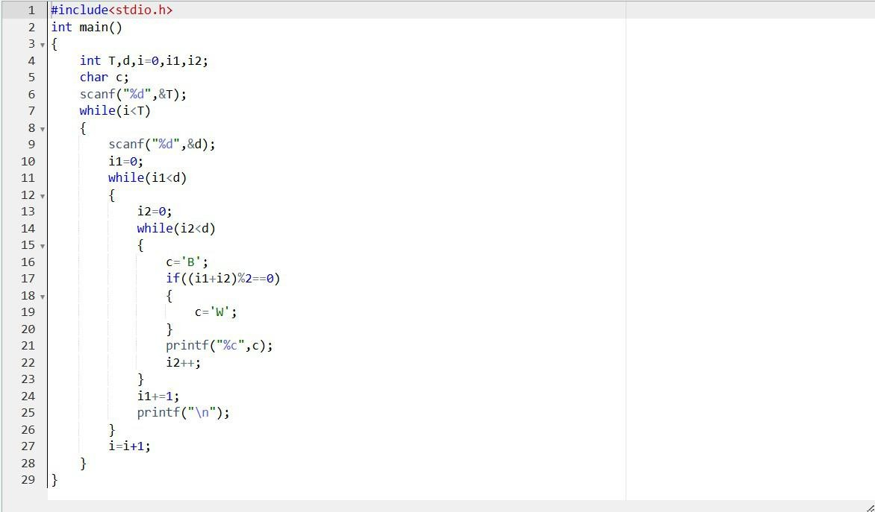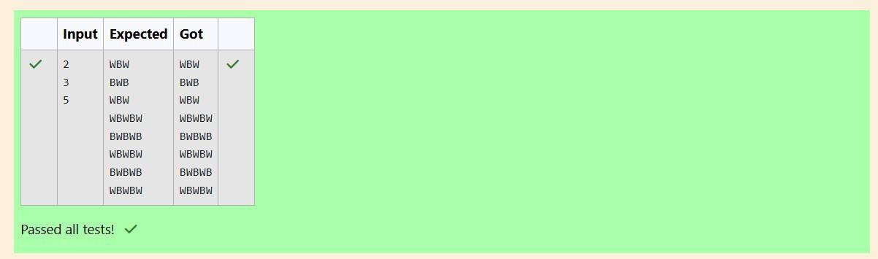

Department of Computer Science and Engineering, Rajalakshmi Engineering College

68

|  |  |
| --- | --- |
| **Ex. No. :** | **Date : 8.11.24** |
|  | **Print Our Own Chessboard** |
| **Problem Statement:**  Let’s print a chessboard!  Write a program that takes input:  The first line contains T, the number of test cases  Each test case contains an integer N and also the starting character of the chessboard  Output Format  Print the chessboard as per the given examples  Sample Input: 2  2 W  3 B  Sample Output: WB  BW BWB WBW BWB | |

Department of Computer Science and Engineering, Rajalakshmi Engineering College

69

### Program:

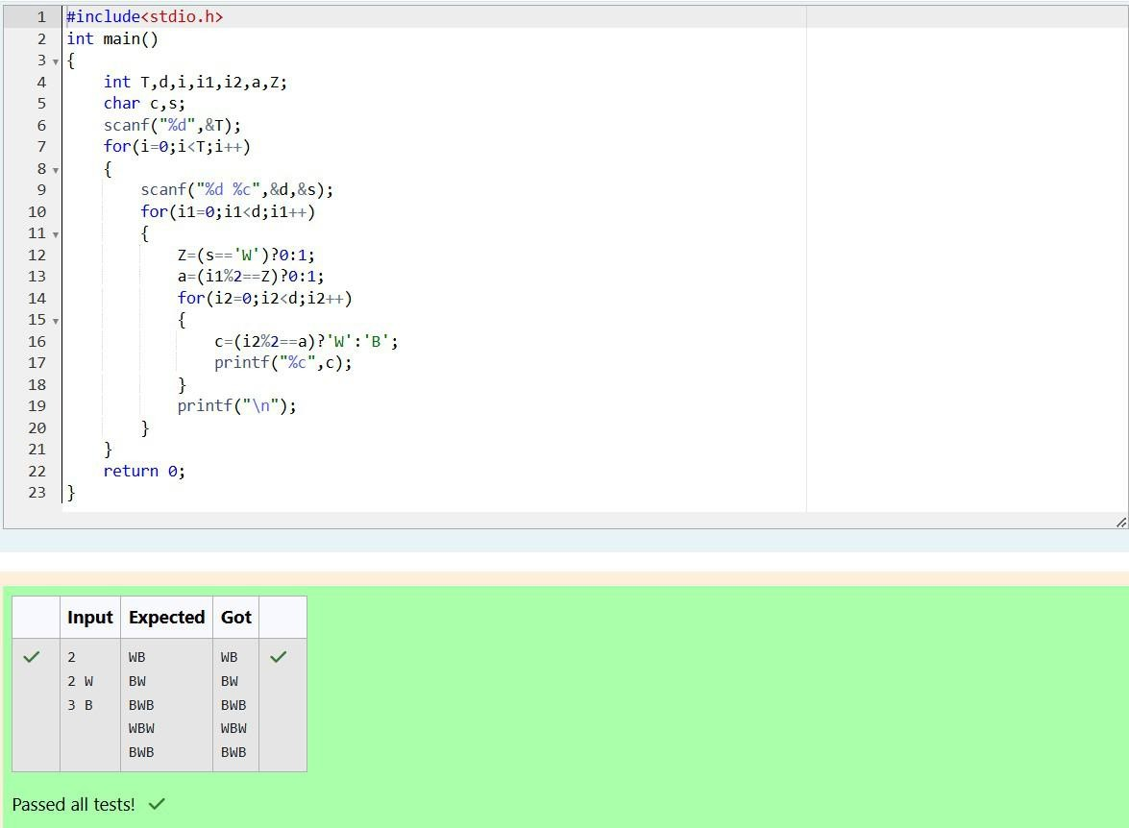

Department of Computer Science and Engineering, Rajalakshmi Engineering College

70

|  |  |
| --- | --- |
| **Ex. No. :** | **Date : 8.11.24** |
|  | **Pattern Printing** |
| **Problem Statement:**  Decode the logic and print the Pattern that corresponds to given input.  If N= 3 then pattern will be:  10203010011012  **4050809  ****607  If N= 4, then pattern will be:  1020304017018019020  **50607014015016  ****809012013  ******10011  Constraints: 2 <= N <= 100 Input Format  First line contains T, the number of test cases, each test case contains a single integer N  Output Format  First line print Case #i where i is the test case number, In the subsequent line, print the pattern  Sample Input 3  3  4  5  Sample Output Case #1  10203010011012  **4050809  ****607  Case #2  1020304017018019020  **50607014015016  ****809012013  ******10011  Case #3  102030405026027028029030  **6070809022023024025  ****10011012019020021  ******13014017018  ********15016 | |

Department of Computer Science and Engineering, Rajalakshmi Engineering College

71

### Program:

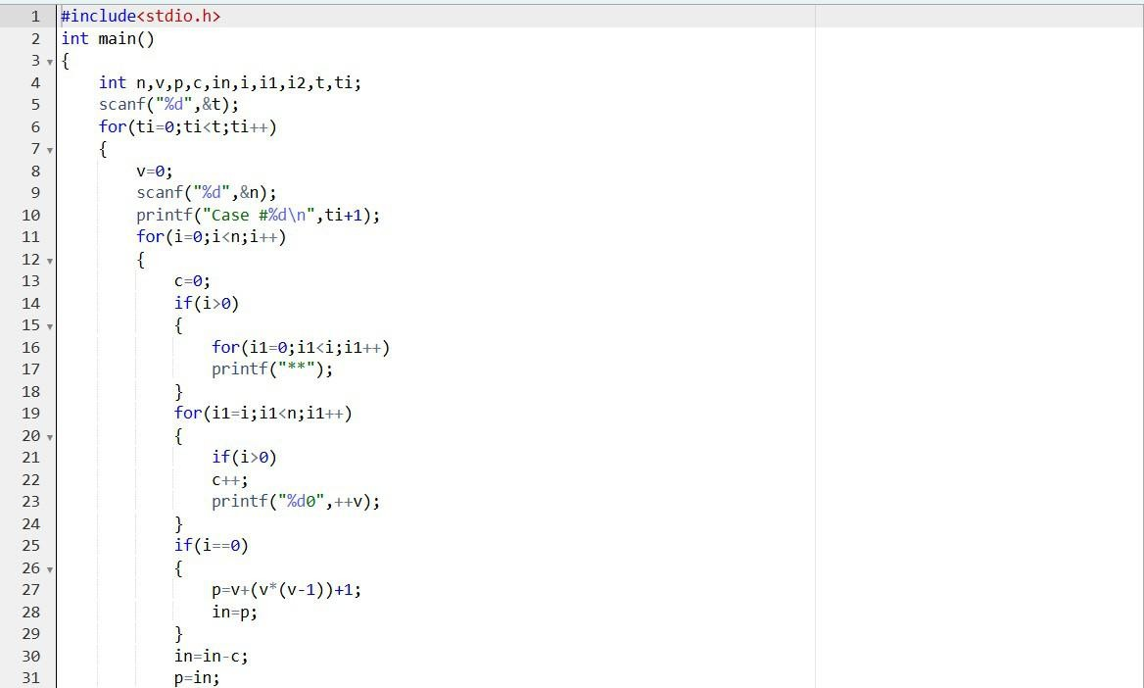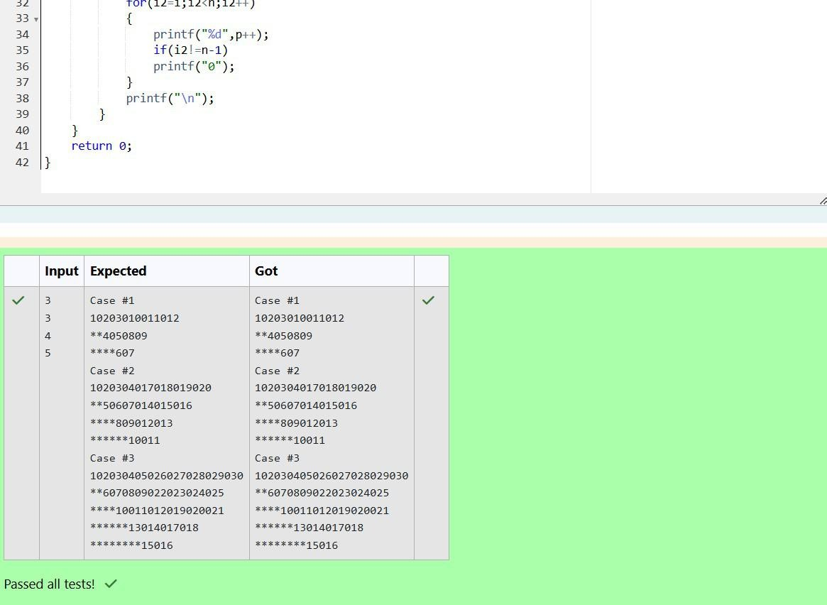

Department of Computer Science and Engineering, Rajalakshmi Engineering College

72

|  |  |
| --- | --- |
| **Ex. No. :** | **Date :13.11.24** |
|  | **Armstrong Number** |
| **Problem Statement:**  The k-digit number N is an Armstrong number if and only if the k-th power of each digit sums to N.  Given a positive integer N, return true if and only if it is an Armstrong number.  **Note**: 1 <= N <= 10^8  **Hint**: 153 is a 3-digit number, and 153 = 1^3 + 5^3 + 3^3.  Sample Input: 153  Sample Output: true  Sample **Input**: 123  Sample **Output**: false  Sample **Input**: 1634  Sample **Output**: true | |

Department of Computer Science and Engineering, Rajalakshmi Engineering College

73

|  |
| --- |
| **Program:** |

Department of Computer Science and Engineering, Rajalakshmi Engineering College

74

|  |  |
| --- | --- |
| **Ex. No. :** | **Date : 13.11.24** |
| **Reverse and Add Until Get a Palindrome** | |
| **Problem Statement:**  Take a number, reverse it and add it to the original number until the obtained number is a palindrome.  Constraints 1<=num<=99999999  Sample Input 1  32  Sample Output 1  55  Sample Input 2  789  Sample Output 2  66066 | |

Department of Computer Science and Engineering, Rajalakshmi Engineering College

75

### Program:

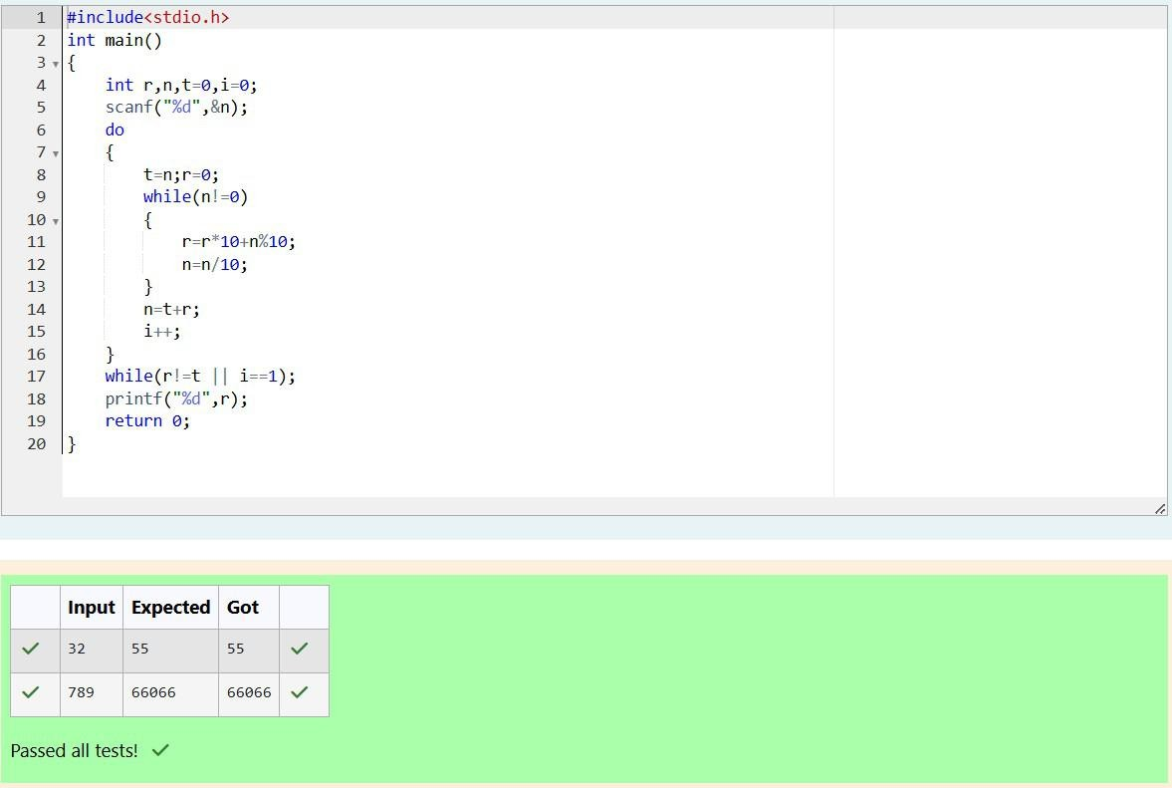

Department of Computer Science and Engineering, Rajalakshmi Engineering College

76

|  |  |
| --- | --- |
| **Ex. No. :** | **Date : 13.11.24** |
|  | **Lucky Number** |
| **Problem Statement:**  A number is considered lucky if it contains either 3 or 4 or 3 and 4 both in it. Write a program to print the nth lucky number. Example, 1st lucky number is 3, and 2nd lucky number is 4 and 3rd lucky number is 33 and 4th lucky number is 34 and so on. Note that 13, 40 etc., are not lucky as they have other numbers in it.  The program should accept a number 'n' as input and display the nth lucky number as output.  Sample Input 1:  3  Sample Output 1:  33 | |

Department of Computer Science and Engineering, Rajalakshmi Engineering College

77

### Program:

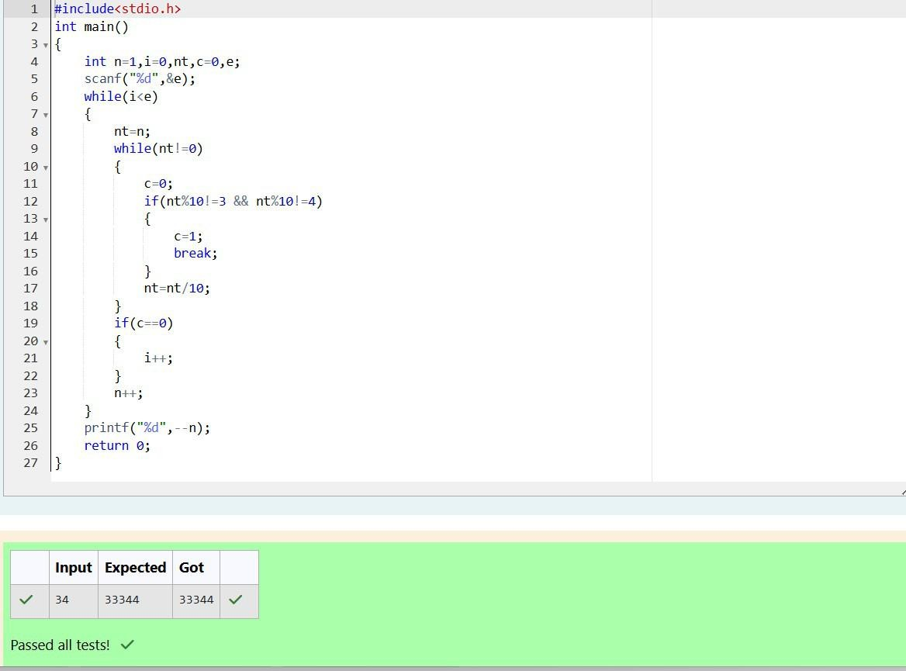

Department of Computer Science and Engineering, Rajalakshmi Engineering College

78

**One-Dimensional Arrays**

Department of Computer Science and Engineering, Rajalakshmi Engineering College

79

|  |  |
| --- | --- |
| **Ex. No. :** | **Date :15.11.24** |
|  | **Check pair with difference k** |
| **Problem Statement:**  Given an array A of sorted integers and another non negative integer k, find if there exists 2 indices i and j such that A[i] - A[j] = k, i != j.  Input Format   1. First line is number of test cases T. Following T lines contain: 2. N, followed by N integers of the array 3. The non-negative integer k   Output format  Print 1 if such a pair exists and 0 if it doesn’t.  Sample Input: 1  3 1 3 5  4  Sample Output: 1 | |

Department of Computer Science and Engineering, Rajalakshmi Engineering College

80

### Program:

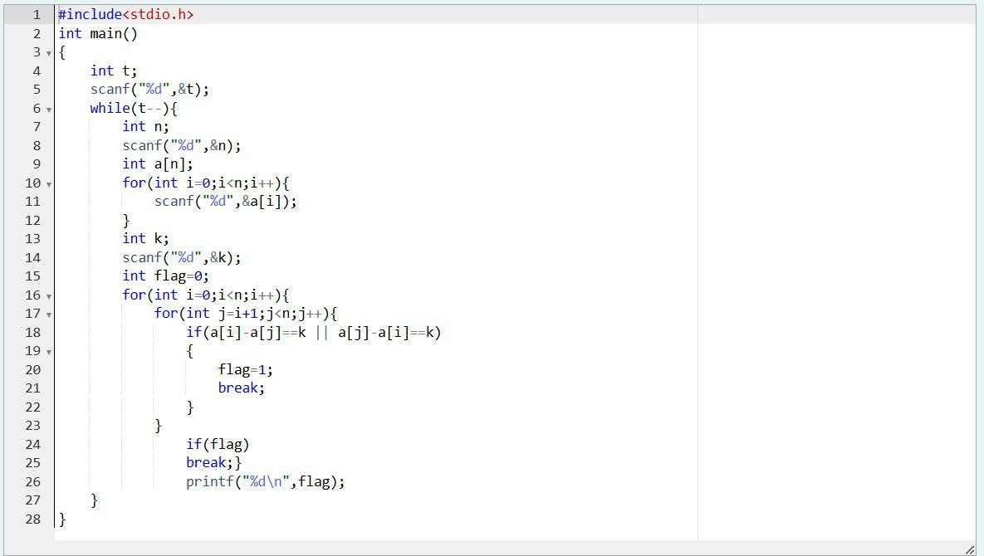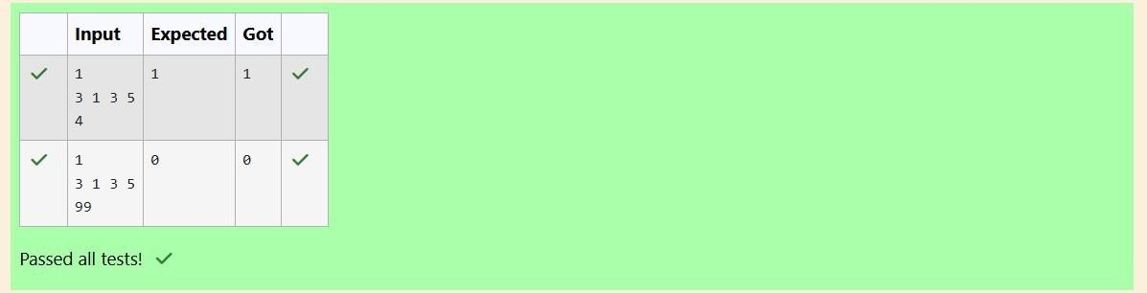

Department of Computer Science and Engineering, Rajalakshmi Engineering College

81

|  |  |
| --- | --- |
| **Ex. No. :** | **Date : 15.11.24** |
|  | **Chocolates** |
| **Problem Statement:**  Sam loves chocolates and starts buying them on the 1st day of the year. Each day of the year, x, is numbered from 1 to Y. On days when x is odd, Sam will buy x chocolates; on days when x is even, Sam will not purchase any chocolates.  Complete the code in the editor so that for each day Ni (where 1 ≤ x ≤ N ≤ Y) in array arr, the number of chocolates Sam purchased (during days 1 through N) is printed on a new line. This is a function-only challenge, so input is handled for you by the locked stub code in the editor.  Input Format  The program takes an array of integers as a parameter.  The locked code in the editor handles reading the following input from stdin, assembling it into an array of integers (arr), and calling calculate(arr).  The first line of input contains an integer, T (the number of test cases). Each line i of  the T subsequent lines describes the ith test case as an integer, Ni (the number of days).  Constraints  1 ≤ T ≤ 2 × 105  1 ≤ N ≤ 2 × 106  1 ≤ x ≤ N ≤ Y  Output Format  For each test case, Ti in arr, your calculate method should print the total number of chocolates Sam purchased by day Ni on a new line.  Sample Input 0  3  1  2  3  Sample Output 0  1  1  4 | |

Department of Computer Science and Engineering, Rajalakshmi Engineering College

82

### Program:

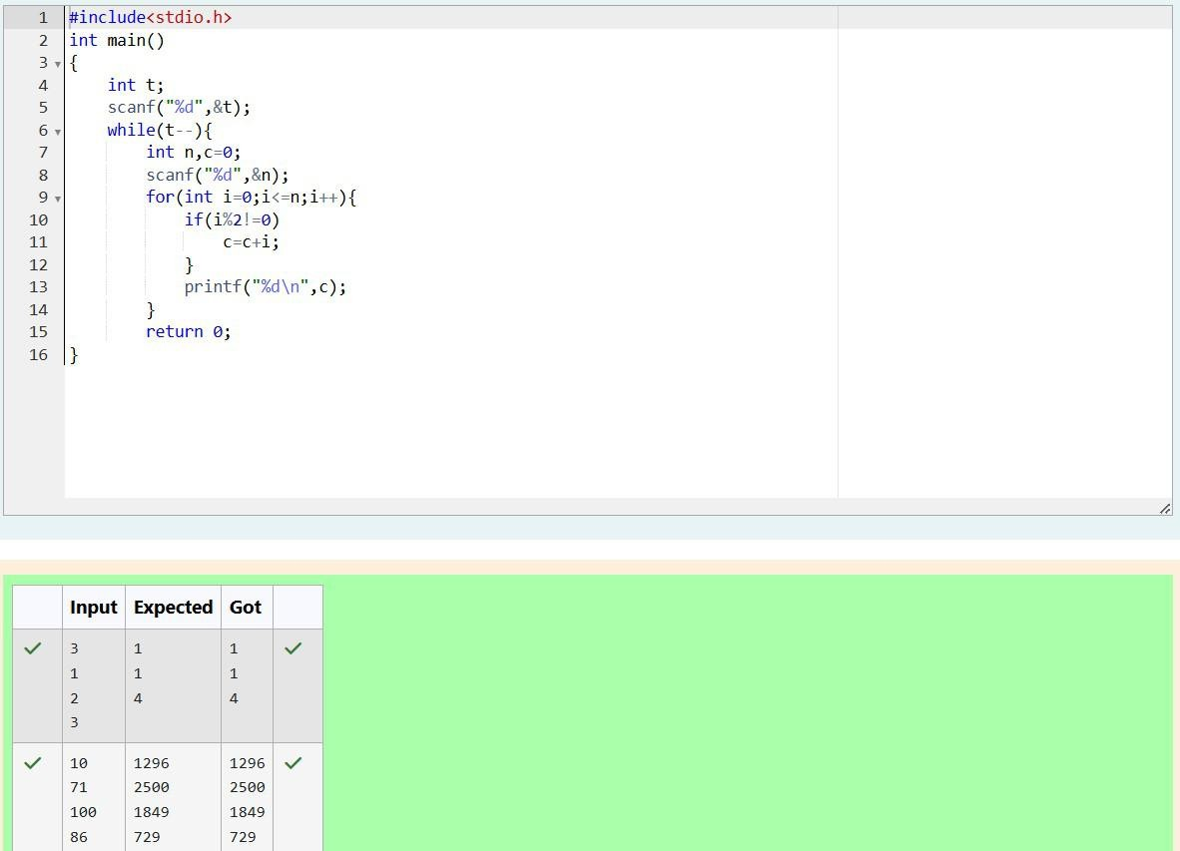

Department of Computer Science and Engineering, Rajalakshmi Engineering College

83

|  |  |
| --- | --- |
| **Ex. No. :** | **Date : 15.11.24** |
|  | **Football Scores** |
| **Problem Statement:**  The number of goals achieved by two football teams in matches in a league is given in the form of two lists. Consider:   * Football team A, has played three matches, and has scored { 1 , 2 , 3 } goals in each match respectively. * Football team B, has played two matches, and has scored { 2, 4 } goals in each match respectively. * Your task is to compute, for each match of team B, the total number of matches of team A, * where team A has scored less than or equal to the number of goals scored by team B in that match.   In the above case:   * For 2 goals scored by team B in its first match, team A has 2 matches with scores 1 and 2. * For 4 goals scored by team B in its second match, team A has 3 matches with scores 1, 2 and 3. Hence, the answer: {2, 3}.   Complete the code in the editor below. The program must return an array of m positive integers, one for each maxes[i] representing the total number of elements nums[j] satisfying nums[j] ≤ maxes[i] where 0 ≤ j < n and 0 ≤ i < m, in the given order.  It has the following:  nums[nums[0],...nums[n-1]]: first array of positive integers maxes[maxes[0],...maxes[n-1]]: second array of positive integers  Constraints:  2 ≤ n, m ≤ 105, 1 ≤ nums[j] ≤ 109, where 0 ≤ j < n, 1 ≤ maxes[i] ≤ 109, where 0 ≤ i < m.  Input Format For Custom Testing  Input from stdin will be processed as follows and passed to the function. The first line contains an integer n, the number of elements in nums.  The next n lines each contain an integer describing nums[j] where 0 ≤ j < n. The next line contains an integer m, the number of elements in maxes.  The next m lines each contain an integer describing maxes[i] where 0 ≤ i < m.  Sample Input 4  1  4  2  4  2  3  5  Sample Output 2  4 | |

Department of Computer Science and Engineering, Rajalakshmi Engineering College

84

|  |
| --- |
| **Program:** |

Department of Computer Science and Engineering, Rajalakshmi Engineering College

85

**Searching Algorithms – Linear and Binary**

Department of Computer Science and Engineering, Rajalakshmi Engineering College

86

|  |  |
| --- | --- |
| **Ex. No. :** | **Date :20.11.24** |
|  | **Ice Cream Parlor** |
| **Problem Statement:**  Sunny and Johnny like to pool their money and go to the ice cream parlor. Johnny never buys the same flavor that Sunny does. The only other rule they have is that they spend all of their money.  Given a list of prices for the flavors of ice cream, select the two that will cost all of the money they have.  For example, they have m = 6 to spend and there are flavors costing cost = [1, 2, 3, 4, 5, 6]. The two flavors costing 1 and 5 meet the criteria. Using 1-based indexing, they are at indices 1 and 4.  Complete the code in the editor below. It should return an array containing the indices of the prices of the two flavors they buy, sorted ascending.  It has the following:   * m: an integer denoting the amount of money they have to spend * cost: an integer array denoting the cost of each flavor of ice cream   **Input Format**  The first line contains an integer, t, denoting the number of trips to the ice cream parlor. The next t sets of lines each describe a visit. Each trip is described as follows:   1. The integer m, the amount of money they have pooled. 2. The integer n, the number of flavors offered at the time. 3. n space-separated integers denoting the cost of each flavor: cost[cost[1], cost[2], .   . . , cost[n]].  Note: The index within the cost array represents the flavor of the ice cream purchased.  **Constraints**   * + 1 ≤ t ≤ 50   + 2 ≤ m ≤ 104   + 2 ≤ n ≤ 104   + 1 ≤ cost[i] ≤ 104,  i  [1, n]   + There will always be a unique solution.   **Output Format**  For each test case, print two space-separated integers denoting the indices of the two flavors purchased, in ascending order.  **Sample Input**  2  4  5  1 4 5 3 2  4  4  2 2 4 3  **Sample Output** 1 4  1 2 | |

Department of Computer Science and Engineering, Rajalakshmi Engineering College

87

|  |
| --- |
| **Program:** |

Department of Computer Science and Engineering, Rajalakshmi Engineering College

88

|  |  |
| --- | --- |
| **Ex. No. :** | **Date : 20.11.24** |
|  | **Missing Numbers** |
| **Problem Statement:**  Numeros the Artist had two lists that were permutations of one another. He was very proud. Unfortunately, while transporting them from one exhibition to another, some numbers were lost out of the first list. Can you find the missing numbers?  As an example, the array with some numbers missing, arr = [7, 2, 5, 3, 5, 3]. The original  array of numbers brr = [7, 2, 5, 4, 6, 3, 5, 3]. The numbers missing are [4, 6].  **Notes**   * If a number occurs multiple times in the lists, you must ensure that the frequency of that number in both lists is the same. If that is not the case, then it is also a missing number. * You have to print all the missing numbers in ascending order. * Print each missing number once, even if it is missing multiple times. * The difference between maximum and minimum number in the second list is less than or equal to 100.   Complete the code in the editor below. It should return a sorted array of missing numbers. It has the following:   * + arr: the array with missing numbers   + brr: the original array of numbers   **Input Format**  There will be four lines of input:  n - the size of the first list, arr  The next line contains n space-separated integers arr[i] m - the size of the second list, brr  The next line contains m space-separated integers brr[i]  **Constraints**  1 ≤ n, m ≤ 2 x 105, n ≤ m, 1 ≤ brr[i] ≤ 2 x 104, Xmax – Xmin < 101  **Output Format**  Output the missing numbers in ascending order.  **Sample Input**  10  203 204 205 206 207 208 203 204 205 206  13  203 204 204 205 206 207 205 208 203 206 205 206 204  **Sample Output**  204 205 206 | |

Department of Computer Science and Engineering, Rajalakshmi Engineering College

89

|  |
| --- |
| **Program:** |

Department of Computer Science and Engineering, Rajalakshmi Engineering College

90

|  |  |
| --- | --- |
| **Ex. No. :** | **Date : 20.11.24** |
|  | **Sherlock and Array** |
| **Problem Statement:**  Watson gives Sherlock an array of integers. His challenge is to find an element of the array such that the sum of all elements to the left is equal to the sum of all elements to the right. For instance, given the array arr = [5, 6, 8, 11], 8 is between two subarrays that sum to 11. If your starting array is [1], that element satisfies the rule as left and right sum to 0. You will be given arrays of integers and must determine whether there is an element that meets the criterion.  Complete the code in the editor below. It should return a string, either YES if there is an element meeting the criterion or NO otherwise. It has the following: arr: an array of integers  Input Format  The first line contains T, the number of test cases. The next T pairs of lines each represent a test case.   * The first line contains n, the number of elements in the array arr. * The second line contains n space-separated integers arr[i] where 0 ≤ i < n. Constraints: 1 ≤ T ≤ 10, 1 ≤ n ≤ 105, 1 ≤ arr[i] ≤ 2 x 104, 0 ≤ i ≤ n   Output Format  For each test case print YES if there exists an element in the array, such that the sum of the elements on its left is equal to the sum of the elements on its right; otherwise print NO.  Sample Input 0  2  3  1 2 3  4  1 2 3 3  Sample Output 0 NO  YES | |

Department of Computer Science and Engineering, Rajalakshmi Engineering College

91

|  |
| --- |
| **Program:** |

Department of Computer Science and Engineering, Rajalakshmi Engineering College

92

**Sorting Algorithms – Bubble and Selection**

Department of Computer Science and Engineering, Rajalakshmi Engineering College

93

|  |  |
| --- | --- |
| **Ex. No. :** | **Date :22.11.24** |
|  | **Easy Going** |
| **Problem Statement:**  Coders here is a simple task for you, you have given an array of size N and an integer M. Your task is to calculate the difference between maximum sum and minimum sum of N-M elements of the given array.  Constraints:  1<=t<=10  1<=n<=1000  1<=a[i]<=1000  Input Format:  First line contains an integer T denoting the number of testcases. First line of every testcase contains two integer N and M.  Next line contains N space separated integers denoting the elements of array  Output:  For every test case print your answer in new line  Sample Input 1  5 1  1 2 3 4 5  Sample Output 4  Explanation  M is 1 and N is 5 so you have to calculate maximum and minimum sum using (5-1 =) 4 elements.  Maximum sum using the 4 elements would be (2+3+4+5=)14. Minimum sum using the 4 elements would be (1+2+3+4=)10. Difference will be 14-10=4. | |

Department of Computer Science and Engineering, Rajalakshmi Engineering College

94

|  |
| --- |
| **Program:** |

Department of Computer Science and Engineering, Rajalakshmi Engineering College

95

|  |  |
| --- | --- |
| **Ex. No. :** | **Date : 22.11.24** |
|  | **Sort it out!** |
| **Problem Statement:**  You are given an array A of non-negative integers of size m. Your task is to sort the array in nondecreasing order and print out the original indices of the new sorted array.  Example:  A={4,5,3,7,1}  After sorting the new array becomes A={1,3,4,5,7}. The required output should be "4 2 0 1 3"  Input Format:  The first line of input consists of the size of the array The next line consists of the array of size m  Output Format:  Output consists of a single line of integers  Constraints:  1<=m<=106  0<=A[i]<=106  NOTE: The indexing of the array starts with 0.  Sample Input 5  4 5 3 7 1  Sample Output 4 2 0 1 3 | |

Department of Computer Science and Engineering, Rajalakshmi Engineering College

96

### Program:

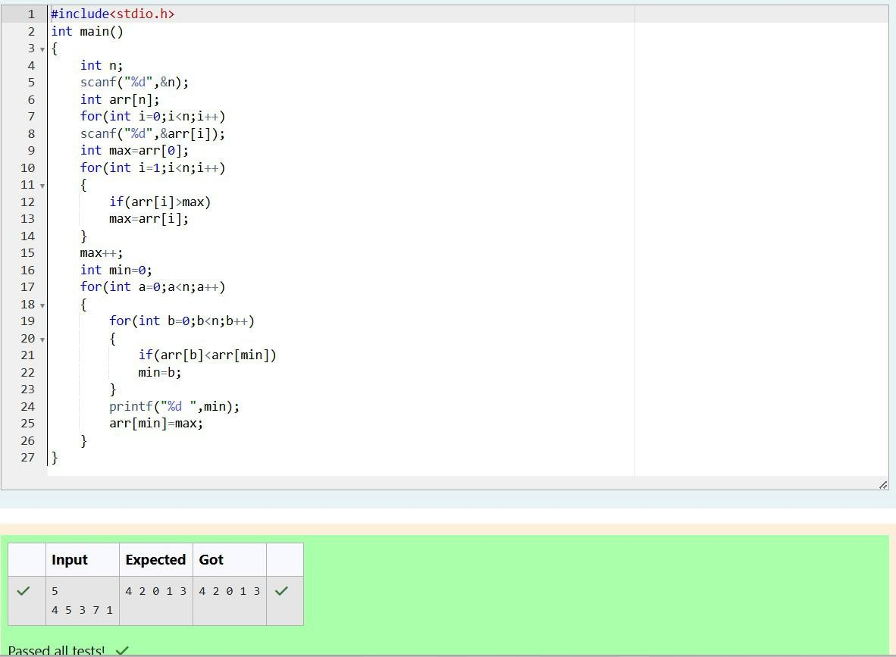

Department of Computer Science and Engineering, Rajalakshmi Engineering College

97

|  |  |
| --- | --- |
| **Ex. No. :** | **Date : 22.11.24** |
|  | **Save Patients** |
| **Problem Statement:**  A new deadly virus has infected large population of a planet. A brilliant scientist has discovered a new strain of virus which can cure this disease. Vaccine produced from this virus has various strength depending on midichlorians count. A person is cured only if midichlorians count in vaccine batch is more than midichlorians count of person. A doctor receives a new set of report which contains midichlorians count of each infected patient, Practo stores all vaccine doctor has and their midichlorians count. You need to determine if doctor can save all patients with the vaccines he has. The number of vaccines and patients are equal.  Input Format  First line contains the number of vaccines - N. Second line contains N integers, which are strength of vaccines. Third line contains N integers, which are midichlorians count of patients.  Output Format  Print a single line containing 'Yes' or 'No'.  Input Constraint 1 < N < 10  Strength of vaccines and midichlorians count of patients fit in integer.  Sample Input 5  123 146 454 542 456  100 328 248 689 200  Sample Output No | |

Department of Computer Science and Engineering, Rajalakshmi Engineering College

98

### Program:

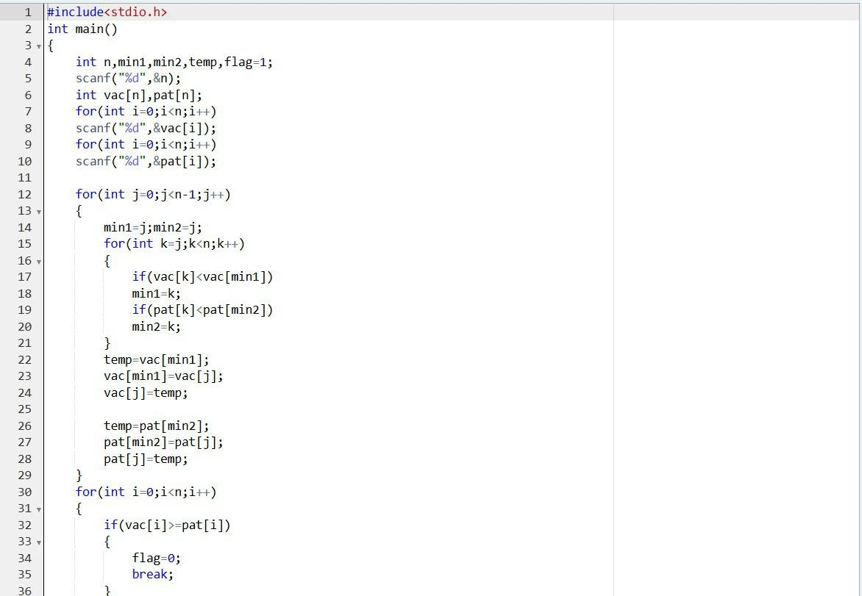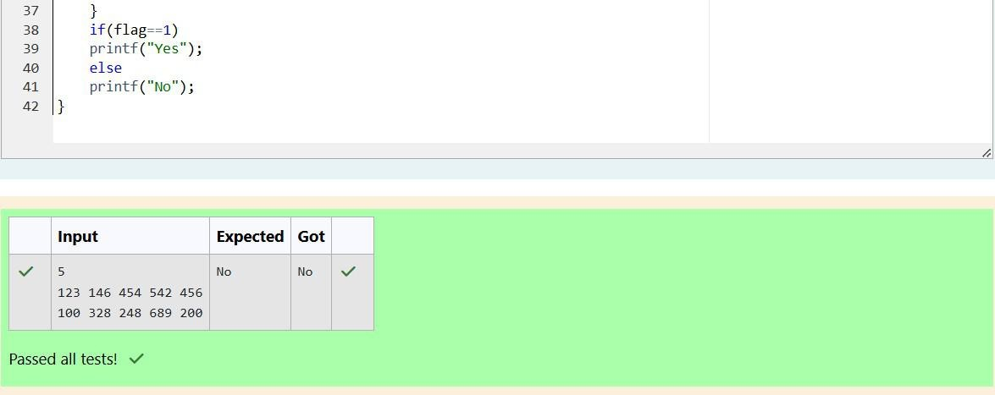

Department of Computer Science and Engineering, Rajalakshmi Engineering College

99

|  |  |
| --- | --- |
| **Ex. No. :** | **Date : 22.11.24** |
|  | **Shubham and Xor** |
| **Problem Statement:**  You are given an array of n integer numbers a1, a2, . . . , an. Calculate the number of pair of indices (i, j) such that 1 ≤ i < j ≤ n and ai xor aj = 0.  Input format   * First line: n denoting the number of array elements * Second line: n space separated integers a1, a2, . . . , an.   Output format  Output the required number of pairs.  Constraints 1 ≤ n ≤ 106  1 ≤ ai ≤ 109  Sample Input 5  1 3 1 4 3  Sample Output 2  Explanation  The 2 pair of indices are (1, 3) and (2,5). | |

Department of Computer Science and Engineering, Rajalakshmi Engineering College

100

### Program:

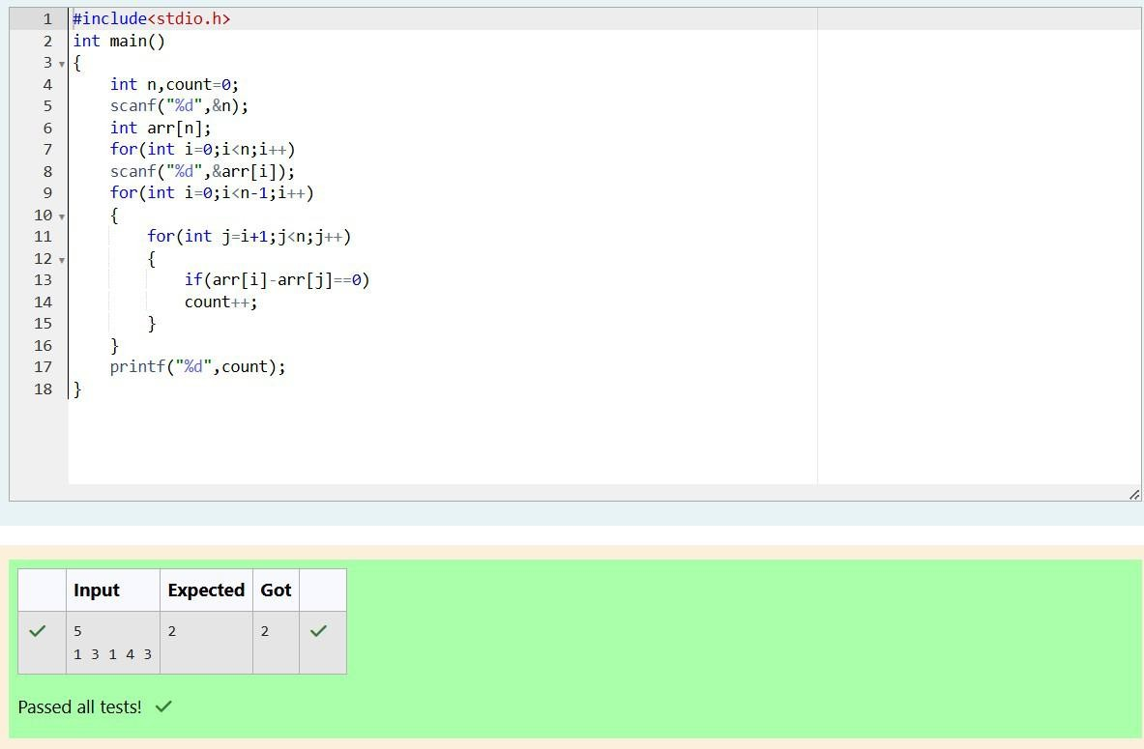

Department of Computer Science and Engineering, Rajalakshmi Engineering College

101

**Two-Dimensional and**

**Multi-Dimensional Arrays**

Department of Computer Science and Engineering, Rajalakshmi Engineering College

102

|  |  |
| --- | --- |
| **Ex. No. :** | **Date :29.11.24** |
| **Add Alternate Elements of 2-Dimensional Array** | |
| **Problem Statement:**  You are given a two-dimensional 3*3 array starting from A [0][0]. You should add the alternate elements of the array and print its sum. It should print two different numbers the first being sum of A 0 0, A 0 2, A 1 1, A 2 0, A 2 2 and A 0 1, A 1 0, A 1 2, A 2 1.  Input Format  First and only line contains the value of array separated by single space.    Output Format  First line should print sum of A 0 0, A 0 2, A 1 1, A 2 0, A 2 2  Second line should print sum of A 0 1, A 1 0, A 1 2, A 2 1  Sample Input  1 2 3 4 5 6 7 8 9  Sample Output 25  20 | |

Department of Computer Science and Engineering, Rajalakshmi Engineering College

103

### Program:

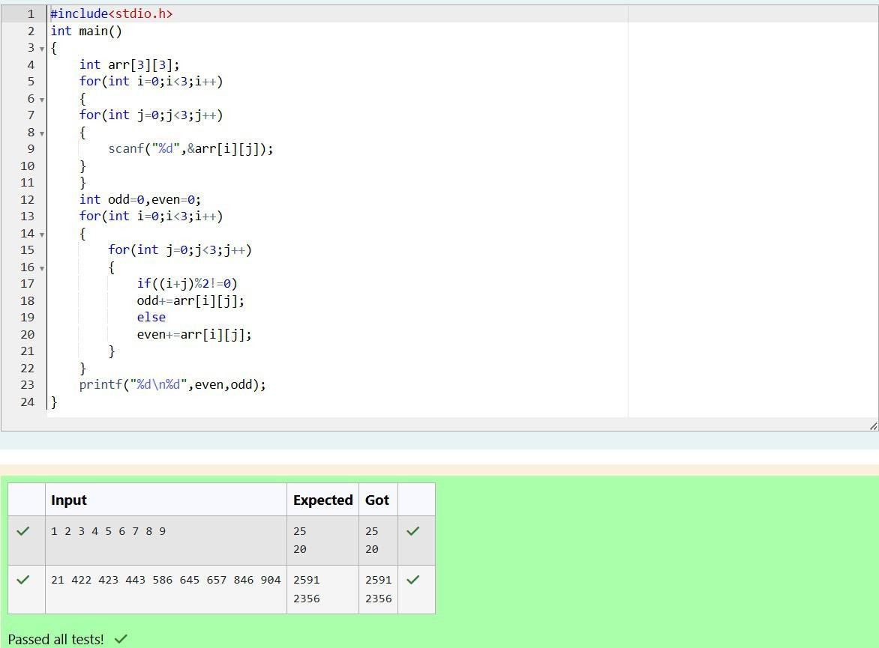

Department of Computer Science and Engineering, Rajalakshmi Engineering College

104

|  |  |
| --- | --- |
| **Ex. No. :** | **Date : 29.11.24** |
|  | **The Wealthy Landlord** |
| **Problem Statement:**  Shyam Lal, a wealthy landlord from the state of Rajasthan, being an old fellow and tired of doing hard work, decided to sell all his farmland and to live rest of his life with that money. No other farmer is rich enough to buy all his land so he decided to partition the land into rectangular plots of different sizes with different cost per unit area. So, he sold these plots to the farmers but made a mistake. Being illiterate, he made partitions that could be overlapping. When the farmers came to know about it, they ran to him for compensation of extra money they paid to him. So, he decided to return all the money to the farmers of that land which was overlapping with other farmer's land to settle down the conflict. All the portion of conflicted land will be taken back by the landlord.  To decide the total compensation, he has to calculate the total amount of money to return back to farmers with the same cost they had purchased from him. Suppose, Shyam Lal has a total land area of 1000 x 1000 equal square blocks where each block is equivalent to a unit square area which can be represented on the co-ordinate axis. Now find the total amount of money, he has to return to the farmers. Help Shyam Lal to accomplish this task.  Input Format:The first line of the input contains an integer N, denoting the total and pieces he had distributed. Next N line contains the 5 space separated integers (X1, Y1), (X2, Y2) to represent a rectangular piece of land, and cost per unit area C.  (X1, Y1) and (X2, Y2) are the locations of first and last square block on the diagonal of the rectangular region.  Output Format:  Print the total amount he has to return to farmers to solve the conflict.  Constraints:  1 ≤ N ≤ 100  1 ≤ X1 ≤ X2 ≤ 1000  1 ≤ Y1 ≤ Y2 ≤ 1000  1 ≤ C ≤ 1000  Sample Input 3  1 4 4 6 1  4 3 6 6 2  2 2 5 4 3  Sample Output 35 | |

Department of Computer Science and Engineering, Rajalakshmi Engineering College

105

|  |
| --- |
| Explanation    For given sample input (see given graph for reference), compensation money for different  farmers is as follows:  Farmer with land area A: C1 = 5 * 1 = 5 Farmer with land area B: C2 = 6 * 2 = 12 Farmer with land area C: C3 = 6 * 3 = 18  Total Compensation Money = C1 + C2 + C3 = 5 + 12 + 18 = 35 |

Department of Computer Science and Engineering, Rajalakshmi Engineering College

106

|  |
| --- |
| **Program:** |

Department of Computer Science and Engineering, Rajalakshmi Engineering College

107

|  |  |
| --- | --- |
| **Ex. No. :** | **Date : 29.11.24** |
|  | **Priority Interview** |
| **Problem Statement:**  Microsoft has come to hire interns from your college. N students got shortlisted out of which few were males and a few females. All the students have been assigned talent levels. Smaller the talent level, lesser is your chance to be selected. Microsoft wants to create the result list where it wants the candidates sorted according to their talent levels, but there is a catch. This time Microsoft wants to hire female candidates first and then male candidates. The task is to create a list where first all-female candidates are sorted in a descending order and then male candidates are sorted in a descending order.  Input Format  The first line contains an integer N denoting the number of students. Next, N lines contain two space-separated integers, ai and bi. The first integer, ai will be either 1(for a male candidate) or 0(for female candidate). The second integer, bi will be the candidate's talent level.  Constraints: 1 <= N <= 105, 0 <= ai <= 1, 1 <= bi <= 109  Output Format  Output space-separated integers, which first contains the talent levels of all female candidates sorted in descending order and then the talent levels of male candidates in descending order.  Sample Input 5  0 3  1 6  0 2  0 7  1 15  Sample Output 7 3 2 15 6 | |

Department of Computer Science and Engineering, Rajalakshmi Engineering College

108

### Program:

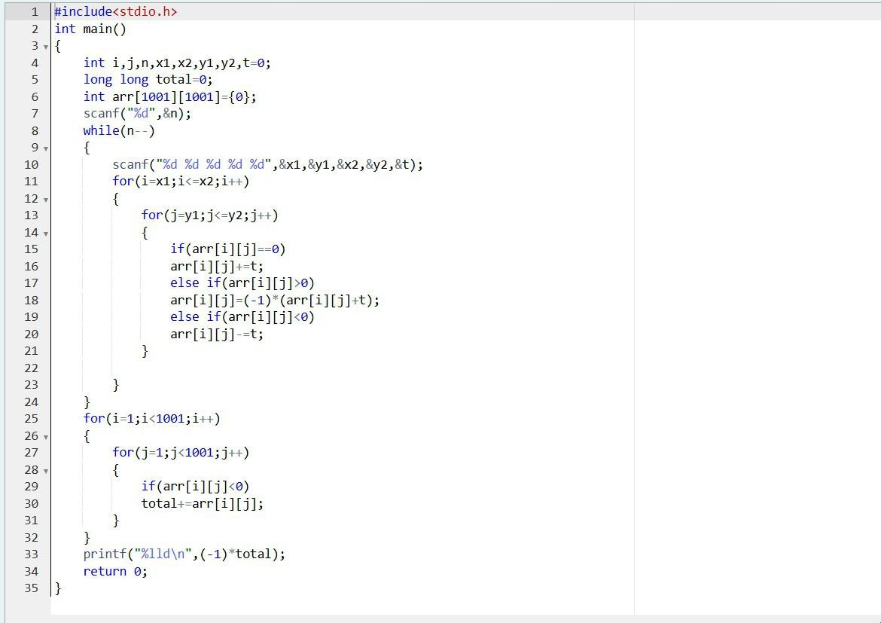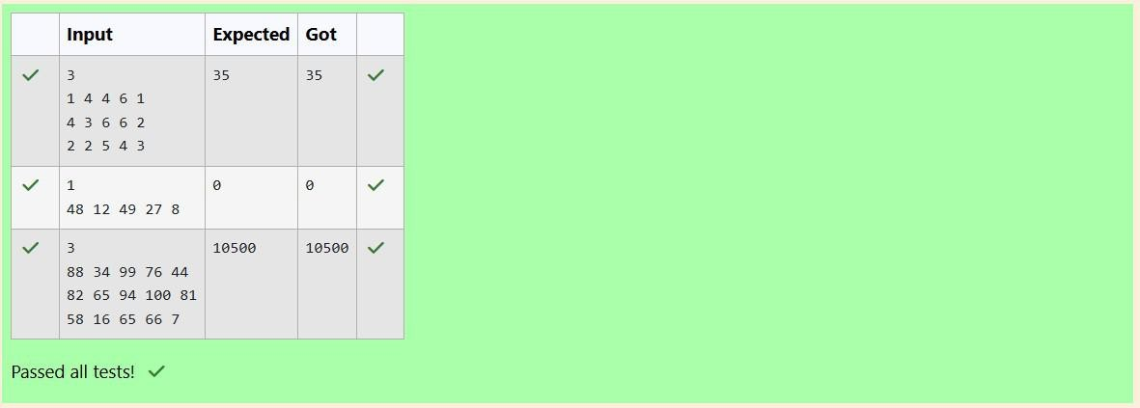

Department of Computer Science and Engineering, Rajalakshmi Engineering College

109

**Character Arrays**

Department of Computer Science and Engineering, Rajalakshmi Engineering College

110

|  |  |
| --- | --- |
| **Ex. No. :** | **Date :11.12.24** |
|  | **Strings** |
| **Problem Statement:**  Input Format  You are given two strings, a and b, separated by a new line. Each string will consist of lower-case Latin characters ('a'-'z').  Output Format  In the first line print two space-separated integers, representing the length of a and b respectively.  In the second line print the string produced by concatenating a and b (a + b).  In the third line print two strings separated by a space, a' and b'. a' and b' are the same as a and b, respectively, except that their first characters are swapped.  Sample Input abcd  ef  Sample Output 4 2  abcdef ebcd af  Explanation  a = "abcd"  b = "ef"  |a| = 4  |b| = 2  a + b = "abcdef" a' = "ebcd"  b' = "af" | |

Department of Computer Science and Engineering, Rajalakshmi Engineering College

111

### Program:

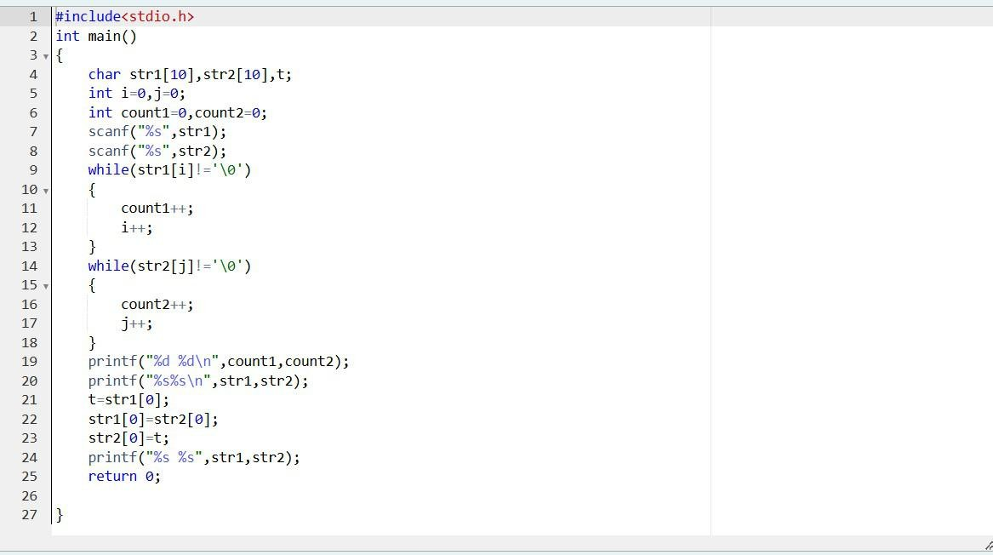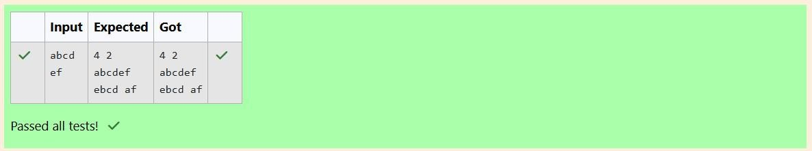

Department of Computer Science and Engineering, Rajalakshmi Engineering College

112

|  |  |
| --- | --- |
| **Ex. No. :** | **Date : 11.12.24** |
|  | **Printing Tokens** |
| **Problem Statement:**  Given a sentence, s, print each word of the sentence in a new line.  **Input Format**  The first and only line contains a sentence, s.  **Constraints**  1 ≤ len(s) ≤ 1000  **Output Format**  Print each word of the sentence in a new line.  **Sample Input**  This is C  **Sample Output**  This is  C  **Explanation**  In the given string, there are three words ["This", "is", "C"]. We have to print each of these words in a new line.  **Hint**  Here, once you have taken the sentence as input, we need to iterate through the input, and keep printing each character one after the other unless you encounter a space. When a space is encountered, you know that a token is complete and space indicates the start of the next token after this. So, whenever there is a space, you need to move to a new line, so that you can start printing the next token. | |

Department of Computer Science and Engineering, Rajalakshmi Engineering College

113

|  |
| --- |
| **Program:** |

Department of Computer Science and Engineering, Rajalakshmi Engineering College

114

|  |  |
| --- | --- |
| **Ex. No. :** | **Date : 11.12.24** |
|  | **Digit Frequency** |
| **Problem Statement:**  Given a string, s, consisting of alphabets and digits, find the frequency of each digit in the given string.  Input Format  The first line contains a string, num which is the given number.  Constraints  1 ≤ len(num) ≤ 1000  All the elements of num are made of English alphabets and digits.  Output Format  Print ten space-separated integers in a single line denoting the frequency of each digit from 0 to 9.  Sample Input 0 a11472o5t6  Sample Output 0  0 2 1 0 1 1 1 1 0 0  Explanation 0  In the given string:   * 1 occurs two times. * 2, 4, 5, 6 and 7 occur one time each. * The remaining digits 0, 3, 8 and 9 don't occur at all.   Hint:   * Declare an array, freq of size 10 and initialize it with zeros, which will be used to count the frequencies of each of the digit occurring. * Given a string, s, iterate through each of the character in the string. Check if the current character is a number or not. * If the current character is a number, increase the frequency of that position in the freq array by 1. * Once done with the iteration over the string, s, in a new line print all the 10 frequencies starting from 0 to 9, separated by spaces. | |

Department of Computer Science and Engineering, Rajalakshmi Engineering College

115

|  |
| --- |
| **Program:** |

Department of Computer Science and Engineering, Rajalakshmi Engineering College

116

|  |  |
| --- | --- |
| **Ex. No. :** | **Date : 11.12.24** |
|  | **Monk Takes a Walk** |
| **Problem Statement:**  Today, Monk went for a walk in a garden. There are many trees in the garden and each tree has an English alphabet on it. While Monk was walking, he noticed that all trees with vowels on it are not in good state. He decided to take care of them. So, he asked you to tell him the count of such trees in the garden.  Note: The following letters are vowels: 'A', 'E', 'I', 'O', 'U', 'a', 'e', 'i', 'o' and 'u'.  Input Format:  The first line consists of an integer T denoting the number of test cases.  Each test case consists of only one string, each character of string denoting the alphabet (may be lowercase or uppercase) on a tree in the garden.  Output Format:  For each test case, print the count in a new line.  Constraints:  1 ≤ T ≤ 10  1 ≤ length of string ≤ 105  Sample Input 2  nBBZLaosnm JHkIsnZtTL  Sample Output 2  1  Explanation  In test case 1, a and o are the only vowels. So, count=2  Brief Description: Given a string S you have to count number of vowels in the string.  Solution 1:  For each vowel, count how many times it is appearing in the string S. Final answer will the sum of frequencies of all the vowels.  Solution 2:  Iterate overall all the characters in the string S and use a counter (variable) to keep track of number of vowels in the string S. While iterating over the characters, if we encounter a vowel, we will increase the counter by 1.  Time Complexity: O(N) where N is the length of the string S. Space Complexity: O(N) | |

Department of Computer Science and Engineering, Rajalakshmi Engineering College

117

|  |
| --- |
| **Program:** |

Department of Computer Science and Engineering, Rajalakshmi Engineering College

118

**String Handling Function**

Department of Computer Science and Engineering, Rajalakshmi Engineering College

119

|  |  |
| --- | --- |
| **Ex. No. :** | **Date :13.12.24** |
|  | **What is your mobile number?** |
| **Problem Statement:**  These days Bechan Chacha is depressed because his crush gave him list of mobile number some of them are valid and some of them are invalid. Bechan Chacha has special power that he can pick his crush number only if he has valid set of mobile numbers. Help him to determine the valid numbers.  You are given a string "S" and you have to determine whether it is Valid mobile number or not. Mobile number is valid only if it is of length 10 , consists of numeric values and it shouldn't have prefix zeroes.  Input Format:  First line of input is T representing total number of test cases.  Next T line each representing "S" as described in in problem statement.  Output Format:  Print "YES" if it is valid mobile number else print "NO". Note: Quotes are for clarity.  Constraints:  1<= T <= 103  sum of string length <= 105  Sample Input 3  1234567890  0123456789  0123456.87  Sample Output YES  NO NO | |

Department of Computer Science and Engineering, Rajalakshmi Engineering College

120

|  |
| --- |
| **Program:** |

Department of Computer Science and Engineering, Rajalakshmi Engineering College

121

|  |  |
| --- | --- |
| **Ex. No. :** | **Date : 13.12.24** |
|  | **Alice and Strings** |
| **Problem Statement:**  Two strings A and B comprising of lower-case English letters are compatible if they are equal or can be made equal by following this step any number of times:   * Select a prefix from the string A (possibly empty), and increase the alphabetical value of all the characters in the prefix by the same valid amount. For example, if the string is xyz and we select the prefix xy then we can convert it to yx by increasing the alphabetical value by 1. But if we select the prefix xyz then we cannot increase the alphabetical value.   Your task is to determine if given strings A and B are compatible.  Input format  First line: String A Next line: String B  Output format  For each test case, print YES if string A can be converted to string B, otherwise print NO.  Constraints  1 ≤ len(A) ≤ 1000000  1 ≤ len(B) ≤ 1000000  Sample Input abaca  cdbda  Sample Output YES  Explanation  The string abaca can be converted to bcbda in one move and to cdbda in the next move. | |

Department of Computer Science and Engineering, Rajalakshmi Engineering College

122

|  |
| --- |
| **Program:** |

Department of Computer Science and Engineering, Rajalakshmi Engineering College

123

|  |  |
| --- | --- |
| **Ex. No. :** | **Date : 13.12.24** |
|  | **Pizza Confusion** |
| **Problem Statement:**  Joey loves to eat Pizza. But he is worried as the quality of pizza made by most of the restaurants is deteriorating. The last few pizzas ordered by him did not taste good :(. Joey is feeling extremely hungry and wants to eat pizza. But he is confused about the restaurant from wherehe should order. As always he asks Chandler for help.  Chandler suggests that Joey should give each restaurant some points, and then choose the restaurant having maximum points. If more than one restaurant has same points, Joey can choose the one with lexicographically smallest name.  Joey has assigned points to all the restaurants, but can't figure out which restaurant satisfies Chandler's criteria. Can you help him out?  Input Format:  First line has N, the total number of restaurants.  Next N lines contain Name of Restaurant and Points awarded by Joey, separated by a space.  Restaurant name has no spaces, all lowercase letters and will not be more than 20 characters.  Output Format:  Print the name of the restaurant that Joey should choose.  Constraints:  1 <= N <= 105  1 <= Points <= 106  Sample Input 3  Pizzeria 108  Dominos 145  Pizzapizza 49  Sample Output Dominos | |

Department of Computer Science and Engineering, Rajalakshmi Engineering College

124

|  |
| --- |
| **Program:** |

Department of Computer Science and Engineering, Rajalakshmi Engineering College

125

|  |  |
| --- | --- |
| **Ex. No. :** | **Date : 13.12.24** |
|  | **Password** |
| **Problem Statement:**  Danny has a possible list of passwords of Manny's facebook account. All passwords length is odd. But Danny knows that Manny is a big fan of palindromes. So, his password and reverse of his password both should be in the list.  You have to print the length of Manny's password and it's middle character. Note: The solution will be unique.  Input Format  The first line of input contains the integer N, the number of possible passwords.  Each of the following N lines contains a single word, its length being an odd number greater than 2 and lesser than 14. All characters are lowercase letters of the English alphabet.  Output Format  The first and only line of output must contain the length of the correct password and its central letter.  Constraints 1 ≤ N ≤ 100  Sample Input 4  abc def feg cba  Sample Output 3 b | |

Department of Computer Science and Engineering, Rajalakshmi Engineering College

126

|  |
| --- |
| **Program:** |

Department of Computer Science and Engineering, Rajalakshmi Engineering College

127

**User-defined Functions & Recursive Functions**

Department of Computer Science and Engineering, Rajalakshmi Engineering College

128

|  |  |
| --- | --- |
| **Ex. No. :** | **Date :18.12.24** |
|  | **Find the Factor** |
| **Problem Statement:**  Determine the factors of a number (i.e., all positive integer values that evenly divide into a number) and then return the pth element of the list, sorted ascending. If there is no pth element, return 0.  Example n = 20  p = 3  The factors of 20 in ascending order are {1, 2, 4, 5, 10, 20}. Using 1-based indexing, if p =  3, then 4 is returned. If p > 6, 0 would be returned.  Function Description  Complete the function pthFactor in the editor below.  pthFactor has the following parameter(s):  int n: the integer whose factors are to be found int p: the index of the factor to be returned  Returns:  int: the long integer value of the pth integer factor of n or, if there is no factor at that index, then 0 is returned  Constraints 1 ≤ n ≤ 1015  1 ≤ p ≤ 109  Input Format for Custom Testing  Input from stdin will be processed as follows and passed to the function. The first line contains an integer n, the number to factor.  The second line contains an integer p, the 1-based index of the factor to return.  Sample Input  STDIN Function    10 → n = 10  3 → p = 3  Sample Output 5  Explanation  Factoring n = 10 results in {1, 2, 5, 10}. Return the p = 3rd factor, 5, as the answer. | |

Department of Computer Science and Engineering, Rajalakshmi Engineering College

129

|  |
| --- |
| **Program:** |

Department of Computer Science and Engineering, Rajalakshmi Engineering College

132

|  |  |
| --- | --- |
| **Ex. No. :** | **Date : 18.12.24** |
|  | **4th Bit** |
| **Problem Statement:**  A binary number is a combination of 1s and 0s. Its nth least significant digit is the nth digit starting from the right starting with 1. Given a decimal number, convert it to binary and determine the value of the the 4th least significant digit.  Example number = 23   * Convert the decimal number 23 to binary number: 2310 = 24 + 22 + 21 + 20 =   (10111)2.   * The value of the 4th index from the right in the binary representation is 0.   Function Description  Complete the function fourthBit in the editor below.  fourthBit has the following parameter(s): int number: a decimal integer  Returns:  int: an integer 0 or 1 matching the 4th least significant digit in the binary representation of number.  Constraints  0 ≤ number < 231  Input Format for Custom Testing  Input from stdin will be processed as follows and passed to the function. The only line contains an integer, number.  Sample Input  STDIN Function    32 → number = 32  Sample Output 0  Explanation   * Convert the decimal number 32 to binary number: 3210 = (100000)2. * The value of the 4th index from the right in the binary representation is 0. | |

Department of Computer Science and Engineering, Rajalakshmi Engineering College

133

|  |
| --- |
| **Program:** |

Department of Computer Science and Engineering, Rajalakshmi Engineering College

134

|  |  |
| --- | --- |
| **Ex. No. :** | **Date : 18.12.24** |
|  | **The Power Sum** |
| **Problem Statement:**  Find the number of ways that a given integer, X, can be expressed as the sum of the Nth powers of unique, natural numbers.  For example, if X = 13 and N = 2, we have to find all combinations of unique squares adding up to 13. The only solution is 22 + 32.  Function Description  Complete the powerSum function in the editor below. It should return an integer that represents the number of possible combinations.  powerSum has the following parameter(s): X: the integer to sum to  N: the integer power to raise numbers to  Input Format  The first line contains an integer X. The second line contains an integer N.  Constraints  1 ≤ X ≤ 1000  2 ≤ N ≤ 10  Output Format  Output a single integer, the number of possible combinations calculated.  Sample Input 10  2  Sample Output 1  Explanation  If X = 10 and N = 2, we need to find the number of ways that 10 can be represented as the sum of squares of unique numbers.  10 = 12 + 32  This is the only way in which 10 can be expressed as the sum of unique squares. | |

Department of Computer Science and Engineering, Rajalakshmi Engineering College

135

|  |
| --- |
| **Program:** |

Department of Computer Science and Engineering, Rajalakshmi Engineering College

136

|  |  |
| --- | --- |
| **Ex. No. :** | **Date : 18.12.24** |
|  | **Hack the Money** |
| **Problem Statement:**  You are a bank account hacker. Initially you have 1 rupee in your account, and you want exactly N rupees in your account. You wrote two hacks, first hack can multiply the amount of money you own by 10, while the second can multiply it by 20. These hacks can be used any number of time. Can you achieve the desired amount N using these hacks.  Constraints:  1<=T<=100  1<=N<=10^12  Input   * The test case contains a single integer N.   Output  For each test case, print a single line containing the string "1" if you can make exactly N rupees or "0" otherwise.  SAMPLE INPUT 1  SAMPLE OUTPUT 1  SAMPLE INPUT 2  SAMPLE OUTPUT 0 | |

Department of Computer Science and Engineering, Rajalakshmi Engineering College

137

|  |
| --- |
| **Program:** |

Department of Computer Science and Engineering, Rajalakshmi Engineering College

142

**Passing Arrays and Strings to Functions**

Department of Computer Science and Engineering, Rajalakshmi Engineering College

143

|  |  |
| --- | --- |
| **Ex. No. :** | **Date :20.12.24** |
|  | **Balanced Array** |
| **Problem Statement:**  Given an array of numbers, find the index of the smallest array element (the pivot), for which the sums of all elements to the left and to the right are equal. The array may not be reordered.  Example: arr=[1,2,3,4,6]   * the sum of the first three elements, 1+2+3=6. The value of the last element is 6. * Using zero based indexing, arr[3]=4 is the pivot between the two subarrays. * The index of the pivot is 3.   Function Description: Complete the function balancedSum in the editor below. balancedSum has the following parameter(s): int arr[n]: an array of integers Returns: int: an integer representing the index of the pivot  Constraints   * 3 ≤ n ≤ 105 * 1 ≤ arr[i] ≤ 2 × 104, where 0 ≤ i < n * It is guaranteed that a solution always exists.   Input Format for Custom Testing  Input from stdin will be processed as follows and passed to the function. The first line contains an integer n, the size of the array arr. Each of the next n lines contains an integer, arr[i], where 0 ≤ i < n.  Sample Input  STDIN Function Parameters    4 → arr[] size n = 4  1 → arr = [1, 2, 3, 3]  2  3  3  Sample Output 0  2  Explanation 0   * The sum of the first two elements, 1+2=3. The value of the last element is 3. * Using zero based indexing, arr[2]=3 is the pivot between the two subarrays. * The index of the pivot is 2. | |

Department of Computer Science and Engineering, Rajalakshmi Engineering College

144

|  |
| --- |
| **Program:** |

Department of Computer Science and Engineering, Rajalakshmi Engineering College

145

|  |  |
| --- | --- |
| **Ex. No. :** | **Date : 20.12.24** |
|  | **Sum Them All** |
| **Problem Statement:**  Calculate the sum of an array of integers.  Example  numbers = [3, 13, 4, 11, 9]  The sum is 3 + 13 + 4 + 11 + 9 = 40.  Function Description  Complete the function arraySum in the editor below.  arraySum has the following parameter(s): int numbers[n]: an array of integers  Returns  int: integer sum of the numbers array  Constraints 1 ≤ n ≤ 104  1 ≤ numbers[i] ≤ 104  Input Format for Custom Testing  Input from stdin will be processed as follows and passed to the function. The first line contains an integer n, the size of the array numbers.  Each of the next n lines contains an integer numbers[i] where 0 ≤ i < n.  Sample Input  STDIN Function    5 → numbers[] size n = 5  1 → numbers = [1, 2, 3, 4, 5]  2  3  4  5  Sample Output 15  Explanation  1 + 2 + 3 + 4 + 5 = 15. | |

Department of Computer Science and Engineering, Rajalakshmi Engineering College

146

|  |
| --- |
| **Program:** |

Department of Computer Science and Engineering, Rajalakshmi Engineering College

147

|  |  |
| --- | --- |
| **Ex. No. :** | **Date : 20.12.24** |
|  | **Minimum Difference Sum** |
| **Problem Statement:**  Given an array of n integers, rearrange them so that the sum of the absolute differences of all adjacent elements is minimized. Then, compute the sum of those absolute differences.  Example  n = 5, arr = [1, 3, 3, 2, 4]  If the list is rearranged as arr' = [1, 2, 3, 3, 4], the absolute differences are |1 - 2| = 1, |2 - 3| = 1,|3 - 3| = 0, |3 - 4| = 1. The sum of those differences is 1 + 1 + 0 + 1 = 3.  Function Description  Complete the function minDiff in the editor below.  minDiff has the following parameter: arr: an integer array  Returns:  int: the sum of the absolute differences of adjacent elements  Constraints  2 ≤ n ≤105  0 ≤ arr[i] ≤ 109, where 0 ≤ i < n  Input Format For Custom Testing  The first line of input contains an integer, n, the size of arr.  Each of the following n lines contains an integer that describes arr[i] (where 0 ≤ i < n) .  Sample Input For Custom Testing STDIN Function    5 → arr[] size n = 5  5 → arr[] = [5, 1, 3, 7, 3]  1  3  7  3  Sample Output 6  Explanation  n = 5, arr = [5, 1, 3, 7, 3]  If arr is rearranged as arr' = [1, 3, 3, 5, 7], the differences are minimized. The final answer is |1 - 3| + |3 - 3| + |3 - 5| + |5 - 7| = 6. | |

Department of Computer Science and Engineering, Rajalakshmi Engineering College

148

|  |
| --- |
| **Program:** |

Department of Computer Science and Engineering, Rajalakshmi Engineering College

149

**Structures and Unions**

Department of Computer Science and Engineering, Rajalakshmi Engineering College

150

|  |  |
| --- | --- |
| **Ex. No. :** | **Date :27.12.24** |
|  | **Boxes through a Tunnel** |
| **Problem Statement:**  You are transporting some boxes through a tunnel, where each box is a parallelepiped, and is characterized by its length, width and height.  The height of the tunnel 41 feet and the width can be assumed to be infinite. A box can be carried through the tunnel only if its height is strictly less than the tunnel's height. Find the volume of each box that can be successfully transported to the other end of the tunnel.  Note: Boxes cannot be rotated.  Input Format  The first line contains a single integer n, denoting the number of boxes.  n lines follow with three integers on each separated by single spaces - lengthi, widthi and heighti which are length, width and height in feet of the i-th box.  Constraints  1 ≤ n ≤ 100  1 ≤ lengthi, widthi, heighti ≤ 100  Output Format  For every box from the input which has a height lesser than 41 feet, print its volume in a separate line.  Sample Input 4  5 5 5  1 2 40  10 5 41  7 2 42  Sample Output 125  80  Explanation  The first box is really low, only 5 feet tall, so it can pass through the tunnel and its volume is 5 x 5 x 5 = 125.  The second box is sufficiently low, its volume is 1 x 2 x 4= = 80.  The third box is exactly 41 feet tall, so it cannot pass. The same can be said about the fourth box. | |

Department of Computer Science and Engineering, Rajalakshmi Engineering College

151

|  |
| --- |
| **Program:** |

Department of Computer Science and Engineering, Rajalakshmi Engineering College

152

|  |  |
| --- | --- |
| **Ex. No. :** | **Date : 27.12.24** |
| **Small Triangles, Large Triangles** | |
| **Problem Statement:**  You are given n triangles, specifically, their sides ai, bi and ci. Print them in the same style but sorted by their areas from the smallest one to the largest one. It is guaranteed that all the areas are different.  The best way to calculate a volume of the triangle with sides a, b and c is Heron's formula: S =  p * (p – a) * (p - b) * (p – c) where p = (a + b + c) / 2.  Input Format  First line of each test file contains single integer n. n lines follow with ai, bi and ci on each separated by single spaces.  Constraints 1 ≤ n ≤ 100  1 ≤ ai, bi, ci ≤ 70  ai + bi > ci, ai + ci > bi and bi + ci > ai  Output Format  Print exactly n lines. On each line print 3 integers separated by single spaces, which are ai, bi and ci of the corresponding triangle.  Sample Input 3  7 24 25  5 12 13  3 4 5  Sample Output 3 4 5  5 12 13  7 24 25  Explanation  The square of the first triangle is 84. The square of the second triangle is 30. The square of the third triangle is 6. So, the sorted order is the reverse one. | |

Department of Computer Science and Engineering, Rajalakshmi Engineering College

153

|  |
| --- |
| **Program:** |

Department of Computer Science and Engineering, Rajalakshmi Engineering College

154

**Pointers**

Department of Computer Science and Engineering, Rajalakshmi Engineering College

155

|  |  |
| --- | --- |
| **Ex. No. :** | **Date :3.1.25** |
|  | **Reverse a List** |
| **Problem Statement:**  Given an array of integers, reverse the given array in place using an index and loop rather than a built-in function.  Example  arr = [1, 3, 2, 4, 5]  Return the array [5, 4, 2, 3, 1] which is the reverse of the input array.  Function Description  Complete the function reverseArray in the editor below.  reverseArray has the following parameter(s): int arr[n]: an array of integers  Return  int[n]: the array in reverse order  Constraints  1 ≤ n ≤ 100  0 < arr[i] ≤ 100  Input Format For Custom Testing  The first line contains an integer, n, the number of elements in arr.  Each line i of the n subsequent lines (where 0 ≤ i < n) contains an integer, arr[i].  Sample Input For Custom Testing 5  1  3  2  4  5  Sample Output 5  4  2  3  1  Explanation  The input array is [1, 3, 2, 4, 5], so the reverse of the input array is [5, 4, 2, 3, 1]. | |

Department of Computer Science and Engineering, Rajalakshmi Engineering College

156

|  |
| --- |
| **Program:** |

Department of Computer Science and Engineering, Rajalakshmi Engineering College

159

|  |  |
| --- | --- |
| **Ex. No. :** | **Date : 3.1.25** |
|  | **Cut Them All** |
| **Problem Statement:**  An automated cutting machine is used to cut rods into segments. The cutting machine can only hold a rod of minLength or more, and it can only make one cut at a time. Given the array lengths [] representing the desired lengths of each segment, determine if it is possible to make the necessary cuts using this machine. The rod is marked into lengths already, in the order given.  Example n = 3  lengths = [4, 3, 2]  minLength = 7  The rod is initially sum(lengths) = 4 + 3 + 2 = 9 units long. First cut off the segment of length 4 + 3 = 7 leaving a rod 9 - 7 = 2. Then check that the length 7 rod can be cut into segments of lengths 4 and 3. Since 7 is greater than or equal to minLength = 7, the final cut can be made. Return "Possible".  Example n = 3  lengths = [4, 2, 3]  minLength = 7  The rod is initially sum(lengths) = 4 + 2 + 3 = 9 units long. In this case, the initial cut can be of length 4 or 4 + 2 = 6. Regardless of the length of the first cut, the remaining piece will be shorter than minLength. Because n - 1 = 2 cuts cannot be made, the answer is "Impossible".  Function Description  Complete the function cutThemAll in the editor below.  cutThemAll has the following parameter(s):  int lengths[n]: the lengths of the segments, in order  int minLength: the minimum length the machine can accept  Returns  string: "Possible" if all n-1 cuts can be made. Otherwise, return the string "Impossible".  Constraints   * 2 ≤ n ≤ 105 * 1 ≤ t ≤ 109 * 1 ≤ lengths[i] ≤ 109 * The sum of the elements of lengths equals the uncut rod length. | |

Department of Computer Science and Engineering, Rajalakshmi Engineering College

160

Input Format For Custom Testing

The first line contains an integer, n, the number of elements in lengths.

Each line i of the n subsequent lines (where 0 ≤ i < n) contains an integer, lengths[i]. The next line contains an integer, minLength, the minimum length accepted by the machine.

Sample Input For Custom Testing

|  |  |  |
| --- | --- | --- |
| STDIN |  | Function |
| 4 | → | lengths[] size n = 4 |
| 3 | → | lengths[] = [3, 5, 4, 3] |
| 5 |  |  |
| 4 |  |  |
| 3 |  |  |
| 9 | → | minLength= 9 |

Sample Output Possible

Explanation

The uncut rod is 3 + 5 + 4 + 3 = 15 units long. Cut the rod into lengths of 3 + 5 + 4

= 12 and 3.

Then cut the 12-unit piece into lengths 3 and 5 + 4 = 9.

The remaining segment is 5 + 4 = 9 units and that is long enough to make the final cut.

Department of Computer Science and Engineering, Rajalakshmi Engineering College

161

|  |
| --- |
| **Program:** |

Department of Computer Science and Engineering, Rajalakshmi Engineering College

# GE23131 - PROGRAMMING USING C

## Viva Questions

### Q1: What is a constant in C?

**A1:** A constant is a value that cannot be altered by the program during execution. Examples include #define directives and const keyword variables.

### Q2: What are the different data types in C?

**A2:** The primary data types in C include int, float, double, char, and void. Derived data types include arrays, pointers, structures, and unions.

### Q3: What is the difference between = and == operators?

**A3:** = is the assignment operator, while == is the equality operator used to compare two values.

### Q4: How do you take input from the user in C?

**A4:** You can take input using functions like scanf() for formatted input or getchar() for character input.

### Q5: What is the difference between if and switch statements?

**A5:** if statements can evaluate any condition, while switch statements work with only integral or enumeration types, making them more efficient in certain cases.

### Q6: Can a switch statement work with strings?

**A6:** No, a switch statement cannot be directly used with strings in C. It only works with integral types like int, char, or enumerations.

### Q7: What is the purpose of a for loop?

**A7:** A for loop is used to execute a block of code repeatedly, usually when the number of iterations is known.

### Q8: What is the difference between while and do-while loops?

**A8:** A while loop checks the condition before executing the loop body, while a do-while loop executes the loop body first and then checks the condition.

### Q9: What is a nested loop?

**A9:** A nested loop is a loop inside another loop. The inner loop is executed multiple times for each iteration of the outer loop.

### Q10: What are jump statements in C?

**A10:** Jump statements include break, continue, goto, and return. They alter the flow of control in a program.

### Q11: How do you declare a one-dimensional array in C?

**A11:** A one-dimensional array is declared as data_type array_name[array_size];.

### Q12: How can you initialize an array during its declaration?

**A12:** You can initialize an array by listing its elements within curly braces, e.g., int arr[5] = {1, 2, 3, 4, 5};.

### Q13: What is linear search?

**A13:** Linear search is a simple searching algorithm that checks each element in an array sequentially until the desired element is found.

### Q14: How does binary search work?

**A14:** Binary search works by repeatedly dividing a sorted array in half, comparing the target value with the middle element, and narrowing the search to either the left or right half.

### Q15: Describe the bubble sort algorithm.

**A15:** Bubble sort repeatedly steps through the list, compares adjacent elements, and swaps them if they are in the wrong order. The pass through the list is repeated until the list is sorted.

### Q16: What is the selection sort algorithm?

**A16:** Selection sort divides the list into a sorted and unsorted part, repeatedly selects the smallest (or largest) element from the unsorted part, and moves it to the sorted part.

### Q17: How do you declare a two-dimensional array in C?

**A17:** A two-dimensional array is declared as data_type array_name[rows][columns];.

### Q18: How can you access an element in a two-dimensional array?

**A18:** You can access an element using its row and column indices, e.g., array_name[row][column];.

### Q19: What is a string in C?

**A19:** A string in C is a sequence of characters terminated by a null character (\0).

### Q20: Name some standard string handling functions in C.

**A20:** Standard string handling functions include strlen(), strcpy(), strcat(), strcmp(), and strstr().

### Q21: What is a recursive function?

**A21:** A recursive function is a function that calls itself to solve a smaller instance of the same problem.

**Q22: Give an example of a problem that can be solved using recursion. A22:** The calculation of the factorial of a number can be solved using recursion.

### Q23: How do you pass an array to a function in C?

**A23:** You pass an array to a function by specifying the array name without brackets, e.g., function_name(array);.

### Q24: Can you modify an array inside a function?

**A24:** Yes, since arrays are passed by reference, you can modify the array elements inside the function.

### Q25: What is the scope of a variable in C?

**A25:** The scope of a variable determines where it can be accessed within the code, such as local, block, function, or file scope.

### Q26: What is the difference between local and global variables?

**A26:** Local variables are declared inside a function or block and can only be accessed within that function or block. Global variables are declared outside all functions and can be accessed by any function in the program.

### Q27: What is a structure in C?

**A27:** A structure is a user-defined data type that allows grouping of variables of different data types under a single name.

### Q28: How do structures differ from unions?

**A28:** In a structure, each member has its own memory location, while in a union, all members share the same memory location.

### Q29: What is a pointer in C?

**A29:** A pointer is a variable that stores the memory address of another variable.

### Q30: How do you declare a pointer?

**A30:** A pointer is declared using the * symbol, e.g., int *ptr;.

### Q31: What is the role of the preprocessor in C?

**A31:** The preprocessor processes directives like #include, #define, and #if before the compilation of the program begins.

### Q32: What is the use of #define in C?

**A32:** #define is used to define macros or symbolic constants that are replaced by the preprocessor before the actual compilation starts.

### Q33: What is the difference between malloc() and calloc()?

**A33:** malloc() allocates memory without initializing it, while calloc() allocates memory and initializes it to zero.

### Q34: How do you handle errors in C?

**A34:** Errors in C can be handled using error codes, errno, or perror() function, and in some cases, setjmp and longjmp functions for error handling.

### Q35: What is the purpose of the return statement in C?

**A35:** The return statement is used to exit a function and optionally return a value to the calling function.

### Q36: What is dynamic memory allocation?

**A36:** Dynamic memory allocation in C allows the allocation of memory during runtime using functions like malloc(), calloc(), realloc(), and free().

### Q37: What is the use of sizeof operator?

**A37:** The sizeof operator returns the size (in bytes) of a data type or variable.

### Q38: Explain the concept of pointer arithmetic.

**A38:** Pointer arithmetic involves operations like addition and subtraction on pointers, which adjust the pointer by a multiple of the size of the data type it points to.

### Q39: What is a segmentation fault?

**A39:** A segmentation fault occurs when a program attempts to access a memory location that it is not allowed to access.

### Q40: How can you prevent buffer overflow?

**A40:** Buffer overflow can be prevented by ensuring that data written to a buffer does not exceed its size, using functions like strncpy() instead of strcpy().

### Q41: What is the difference between auto, static, and extern storage classes in C? A41:

* auto: The default storage class for local variables, with automatic storage duration.
* static: Retains the value of a variable between function calls and limits its scope to the file (for global variables) or block (for local variables).
* extern: Declares a global variable or function that is defined in another file, making it accessible across multiple files.

### Q42: What are bitwise operators, and how are they used in C?

**A42:** Bitwise operators perform operations on the individual bits of integer types. They include & (AND), | (OR), ^ (XOR), ~ (NOT), << (left shift), and >> (right shift).

### Q43: How do you differentiate between call by value and call by reference in C? A43:

* **Call by value**: Copies the actual value of an argument into the formal parameter of the function. Changes made to the parameter inside the function have no effect on the argument.
* **Call by reference**: Passes the address of an argument, allowing the function to modify the argument’s value.

### Q44: What is a function pointer, and how is it used?

**A44:** A function pointer is a pointer that points to the address of a function. It can be used to call the function or pass a function as an argument to another function.

### Q45: Explain the difference between a deep copy and a shallow copy in the context of structures.

**A45:**

* **Shallow copy**: Copies the values of the structure's fields, including pointers, but does not copy the objects pointed to by the pointers.
* **Deep copy**: Copies the values of the structure's fields and recursively copies the objects pointed to by the pointers, creating new instances.

### Q46: How can you dynamically allocate a 2D array in C?

**A46:** You can dynamically allocate a 2D array using an array of pointers or by using a single pointer to allocate a contiguous block of memory.

### Q47: What are the main differences between arrays and pointers in C? A47:

* Arrays have a fixed size and store multiple elements of the same type.
* Pointers store the memory address of a variable and can point to any memory location, allowing dynamic memory allocation and manipulation.

### Q48: How does the realloc() function work, and when would you use it?

**A48:** realloc() resizes an already allocated memory block. It's used when you need to increase or decrease the size of an existing dynamically allocated array or buffer.

### Q59: What is a memory leak, and how can you prevent it?

**A59:** A memory leak occurs when dynamically allocated memory is not properly deallocated using free(), leading to reduced available memory. It can be prevented by ensuring all allocated memory is freed when no longer needed.

### Q50: What is a header file in C, and why is it used?

**A50:** A header file is a file with a .h extension that contains declarations of functions, macros, and constants. It is included in other C files using #include to facilitate code reuse and organization.

### Q51: What is a function prototype in C?

**A51:** A function prototype is a declaration of a function that specifies the function’s name, return type, and parameters without providing the function body. It allows the function to be called before its actual definition.

### Q52: What is the purpose of the return statement in a function?

**A52:** The return statement is used to exit a function and return a value to the calling function. It can also be used to terminate a void function early.

### Q53: What does the const keyword do when applied to a variable?

**A53:** The const keyword makes a variable read-only, meaning its value cannot be modified after it is initialized.

### Q54: How do you declare and initialize a pointer to a function?

**A54:** You declare a function pointer with the syntax return_type (*pointer_name)(parameter_list);. For example: int (*funcPtr)(int, int);. It is initialized by assigning it the address of a function with a compatible signature.

### Q55: What is pointer dereferencing, and how is it done?

**A55:** Pointer dereferencing is accessing the value stored at the memory address a pointer is pointing to. It is done using the * operator, e.g., int value = *ptr;.

### Q56: Explain the difference between calloc() and malloc().

**A56:** malloc() allocates a block of memory without initializing it, while calloc() allocates memory and initializes all bytes to zero.

### Q57: How can you determine the length of a string in C?

**A57:** The length of a string can be determined using the strlen() function, which returns the number of characters before the null terminator (\0).

### Q58: What is the significance of the null character \0 in strings?

**A58:** The null character \0 signifies the end of a string in C. It is used to determine the string's length and prevent buffer overflows during string operations.

### Q59: How do you pass a structure to a function?

**A59:** A structure can be passed to a function either by value (copying the structure) or by reference (passing a pointer to the structure).

### Q60: What is the use of the sizeof operator in C?

**A60:** The sizeof operator returns the size, in bytes, of a data type or variable. It is often used to allocate memory dynamically or determine array sizes.

### Q61: Explain the concept of typecasting in C.

**A61:** Typecasting in C is the conversion of a variable from one data type to another. This is done explicitly by placing the target data type in parentheses before the variable or expression.

### Q62: How do you differentiate between an array of pointers and a pointer to an array?

**A62:** An array of pointers is a collection of pointers, each pointing to different data, while a pointer to an array points to the first element of a single array.

### Q63: What is the purpose of the break statement in a loop?

**A63:** The break statement is used to exit a loop or switch statement immediately, regardless of the loop's condition.

### Q64: What is recursion, and when should it be used?

**A64:** Recursion is a technique where a function calls itself to solve a smaller instance of the problem. It should be used when a problem can be broken down into smaller, similar subproblems, like in factorials, Fibonacci sequence, etc.

### Q65: How do you access the members of a structure using a pointer?

**A65:** Structure members can be accessed using a pointer with the -> operator, e.g., ptr->member.

### Q66: What is the purpose of the volatile keyword in C?

**A66:** The volatile keyword tells the compiler that a variable's value may change at any time, preventing the compiler from optimizing code that assumes the variable's value is stable.

### Q67: Explain the difference between stack memory and heap memory.

**A67:** Stack memory is used for static memory allocation (e.g., local variables), and it is managed automatically. Heap memory is used for dynamic memory allocation, and it must be manually managed by the programmer using malloc, calloc, free, etc.

### Q68: What is the significance of the #include directive?

**A68:** The #include directive is used to include the contents of a file (usually a header file) in the program at the point where the directive appears.

### Q69: What is the use of the #pragma directive?

**A69:** The #pragma directive is used to provide special instructions to the compiler, such as controlling optimizations or aligning data in memory.

### Q70: How do you handle file operations in C?

**A70:** File operations in C are handled using standard library functions like fopen, fclose, fread, fwrite, fprintf, fscanf, and fseek.

### Q71: What is the difference between text mode and binary mode in file handling?

**A71:** In text mode, file data is processed as sequences of characters, where newline characters are translated. In binary mode, data is processed as raw bytes without any translation.

### Q72: How can you create an infinite loop in C?

**A72:** An infinite loop can be created using a loop that never meets its termination condition, e.g., while(1) or for(;;).

### Q73: What is the role of the fseek() function in file handling?

**A73:** The fseek() function is used to move the file pointer to a specific location within the file, enabling random access to file content.

### Q74: What are command-line arguments, and how are they used in C?

**A74:** Command-line arguments are parameters passed to the main() function when a program is executed. They are used to influence the program’s behavior based on user input at runtime.

### Q75: Explain the difference between fgets() and gets() functions.

**A75:** fgets() reads a line from a file or standard input up to a specified number of characters or until a newline is encountered, and it includes the newline in the string. gets() reads a line until a newline but does not limit the number of characters, which can lead to buffer overflows.

### Q76: What is an array index out of bounds error?

**A76:** An array index out of bounds error occurs when you try to access an element of an array using an index that is outside the valid range (0 to size-1). This can lead to undefined behavior.

### Q77: How do you initialize a pointer to NULL? Why is it important?

**A77:** A pointer is initialized to NULL using the assignment ptr = NULL;. It is important to initialize pointers to NULL to avoid them pointing to random memory locations, which can lead to crashes when dereferenced.

### Q78: Explain what a dynamic array is and how you can implement it in C.

**A78:** A dynamic array is an array whose size can be changed during runtime. It can be implemented using malloc() or calloc() to allocate memory and realloc() to resize it.

### Q79: What are unions in C, and how are they different from structures?

**A79:** Unions are similar to structures, but in a union, all members share the same memory location, so it can only hold one value at a time. Structures allocate separate memory for each member.

### Q80: What is the purpose of the static keyword when used in a function?

**A80:** When used in a function, the static keyword makes the function’s local variables retain their value between function calls. It also limits the scope of the function or variable to the file in which it is declared.

### Q81: How can you swap two variables using pointers?

**A81:** Two variables can be swapped using pointers by accessing and modifying their values via the pointers, typically using a temporary variable to hold one of the values during the swap.

### Q82: What is pointer-to-pointer in C?

**A82:** A pointer-to-pointer is a pointer that stores the address of another pointer, allowing for multiple levels of indirection.

### Q83: Explain the difference between printf and sprintf.

**A83:** printf outputs formatted text to the standard output (usually the screen), while sprintf writes the formatted text into a string buffer.

### Q84: What is a segmentation fault, and how can it be caused?

**A84:** A segmentation fault is a runtime error that occurs when a program tries to access a memory location that it is not allowed to access, often caused by dereferencing null or uninitialized pointers or accessing memory out of bounds.

### Q85: What is the purpose of the #ifndef directive?

**A85:** The #ifndef directive checks whether a macro is not defined. If it is not defined, the code that follows is included in the compilation. It is commonly used to prevent multiple inclusions of the same header file.

### Q86: How do you use command-line arguments in a C program?

**A86:** Command-line arguments are accessed in the main() function via the argc (argument count) and argv (argument vector) parameters. argc gives the number of arguments, and argv is an array of strings representing the arguments.

### Q87: Explain how memory is managed in C.

**A87:** Memory management in C involves allocating memory dynamically using malloc(), calloc(), or realloc() and freeing it using free(). The programmer is responsible for managing the memory to avoid leaks and corruption.

### Q88: What is the difference between postfix and prefix increment/decrement operators?

**A88:** Prefix (++i or --i) increments or decrements the value before the expression is evaluated, while postfix (i++ or i--) does so after the expression is evaluated.

### Q89: How can you prevent buffer overflows in C?

**A89:** Buffer overflows can be prevented by ensuring that you do not write more data into a buffer than it can hold. Functions like fgets() and snprintf() should be used instead of gets() and sprintf().

### Q90: What is the purpose of using void in function declarations?

**A90:** The void keyword in function declarations indicates that the function does not return a value (when used as a return type) or that it does not take any parameters (when used in the parameter list).

### Q91: What are preprocessor directives, and how are they used?

**A91:** Preprocessor directives are commands that are executed by the preprocessor before the actual compilation of the code begins. Examples include #define, #include, #if, #else, and #endif.

### Q92: How do you pass an array to a function in C?

**A92:** You pass an array to a function by passing a pointer to the first element of the array. The function receives this pointer and can access the array elements via pointer arithmetic.

### Q93: What is the difference between a #define macro and a const variable?

**A93:** A #define macro is a preprocessor directive that defines a constant value or expression that is replaced by the preprocessor. A const variable is a constant value that has a data type and is checked by the compiler.

### Q94: What is the purpose of the #undef directive?

**A94:** The #undef directive is used to undefine a previously defined macro, making it no longer available in the subsequent code.

### Q95: Explain the concept of variable shadowing.

**A95:** Variable shadowing occurs when a local variable in a block has the same name as a variable in an outer scope, effectively hiding or "shadowing" the outer variable within that block.

### Q96: What is the difference between exit() and return in C?

**A96:** return is used to exit a function and optionally return a value to the calling function. exit() terminates the entire program, returning a status code to the operating system.

### Q97: How do you handle errors in file operations?

**A97:** Errors in file operations can be handled by checking the return values of file functions (e.g., fopen, fread, fwrite) and using the perror() or strerror() functions to display error messages.

### Q98: What is the purpose of the assert() function?

**A98:** The assert() function is used to perform runtime checks, terminating the program if a given expression evaluates to false. It is often used for debugging.

### Q99: How can you implement a basic stack using arrays?

**A99:** A stack can be implemented using an array by maintaining an index (top) that tracks the last pushed element. Operations like push, pop, and peek can be defined using this index.

### Q100: What is dynamic memory allocation, and why is it important?

**A100:** Dynamic memory allocation allows a program to allocate memory at runtime based on its needs, making it flexible and efficient in managing memory for data structures like linked lists and trees.

